Adding an appointment in Well Sky- aka webappts  At the top of the screen select the tab with containing the schedule of the person you want to schedule.  Using the calendar in left margin select the date for the appointment.  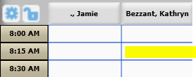  Select the timeslot with the time of the appointment in the column of the person you want to schedule.  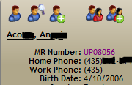  Begin to type in child’s last name, a pop-up screen will appear, select the child’s name and click select in the bottom right corner of the pop-up screen. The child information will appear in the left margin of the screen .  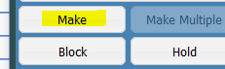  Another pop-up screen will appear. Select “make” from the pop-up screen.  Select appointment types. A pop-up screen will appear. Begin typing the type of appointment you are scheduling in the field at the top, e.g. Big Talker- Logan, BDI evaluation. Select the type of appointment from the list and click select. A pop-up screen may open asking to extend duration of the appointment- select “yes”. Select continue in top right corner. If the appointment you are scheduling overlaps or is in the same timeslot as another appointment for this child or employee a pop-up screen will appear.  - Select “Quick Book” if you want appointments to occur at the same time or select Cancel at top and select another date and time.  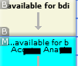  - The timeslot will be populated with the type of appointment. | Blocking time, Reserving a BDI kit  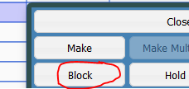  Same directions as making an appointment but select the timeslot. You can select multiple timeslots e.g. 9:00am- 12:00pm by right clicking on the box with the start time and dragging down to the ending timeslot.  Click on the Select button at the top left of screen.  Begin typing the type of time you want to block e.g., BDI, holiday, vacation. Select the type of appointment from the list and click select. Add any comments that you want other to see in comment section. Click Continue at top right corner.  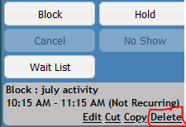  Deleting or editing an appointment  Click on the appointment you want to delete or edit. A pop-up screen will appear. You can select the action at the bottom of the pop-up screen.
Adding New Children or Reactivating in BTOTS & Well Sky  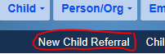  Entering or reactivating a new child in BTOTS  Select New Child Referral at top of the BTOTs home page. Select Referral Source, enter child’s First Name and Last Name, select Gender, enter Date of Birth  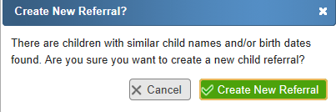  Select next. BTOTS will check for existing children. Look carefully to see if the child you are entering has already been referred to Up to 3 or other Utah EI. You can select Details on the right side to see Primary Family Members names. Select the child if he/she has been previously referred. You will receive this message. Double check to make sure that the child doesn’t already have a record.  If not, select New Child Referral/non-matching.  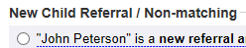  Select next. Follow BTOT wizard instructions entering the information you collected on the Up to 3 Intake Form.  Adding or reactivating a child in Well Sky- aka webappts  If you find the child is already entered into BTOTS the child should also be in Well Sky. Follow the directions to reactivate in Well Sky.  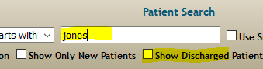  How to Reactivate a Deactivated Child in Well Sky  -Start typing in child’s name on the grid. A pop-up box will appear. The name you are typing will appear in Patient Search box, check the Show Discharged Patients box. This will open up children that have been deactivated.  -Look down the list and find the child’s name. Make sure you check the birthdates to make sure it is the same child. Click on the child’s name you are reactivating then hit select. | 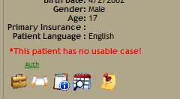  -Child’s name will appear on the left side of your screen, and there will be a message in red saying *This patient has no usable case!  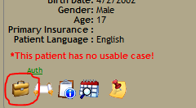  -Under the child’s name there is a symbol that looks like a briefcase, click on this symbol.  -A pop-up screen will appear. The tab Cases will be highlighted in Red.  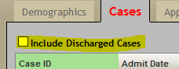  -Check the box next to the “Include Discharged Cases.” This will bring up the child’s UP# and discharge date.  -On the right side click on the word edit  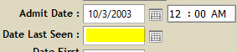  -In this box erase the Date Last Seen and click on the “Un-Discharge” button.  -Click save in the bottom right corner. This will reactivate this child’s case.  -Click on the child’s name on the left hand side of the grid page and double check that their address and phone #’s are still accurate.  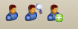  Entering new child into Well Sky  On the Grid Page of Well Sky look for the child icon with the green plus sign. Click on this symbol. This will bring up a blank Patient Information page.  Add the following information that is highlighted in red:  -First Name -Last Name -Birth Date -Address -Home Phone #  ***Make sure to click save at the bottom or all the information will be lost.  -Miriam will add the remaining information.  You can now enter appointments for this child.
Adding an appointment in Well Sky- aka webappts

At the top of the screen select the tab with containing the schedule of the person you want to schedule.

Using the calendar in left margin select the date for the appointment.
Select the timeslot with the time of the appointment in the column of the person you want to schedule.

Begin to type in child’s last name, a pop-up screen will appear, select the child’s name and click select in the bottom right corner of the pop-up screen. The child information will appear in the left margin of the screen .

Another pop-up screen will appear. Select “make” from the pop-up screen.

Select appointment types. A pop-up screen will appear. Begin typing the type of appointment you are scheduling in the field at the top, e.g. Big Talker- Logan, BDI evaluation. Select the type of appointment from the list and click select. A pop-up screen may open asking to extend duration of the appointment- select “yes”. Select continue in top right corner. If the appointment you are scheduling overlaps or is in the same timeslot as another appointment for this child or employee a pop-up screen will appear.
- Select “Quick Book” if you want appointments to occur at the same time or select Cancel at top and select another date and time.
- The timeslot will be populated with the type of appointment.

