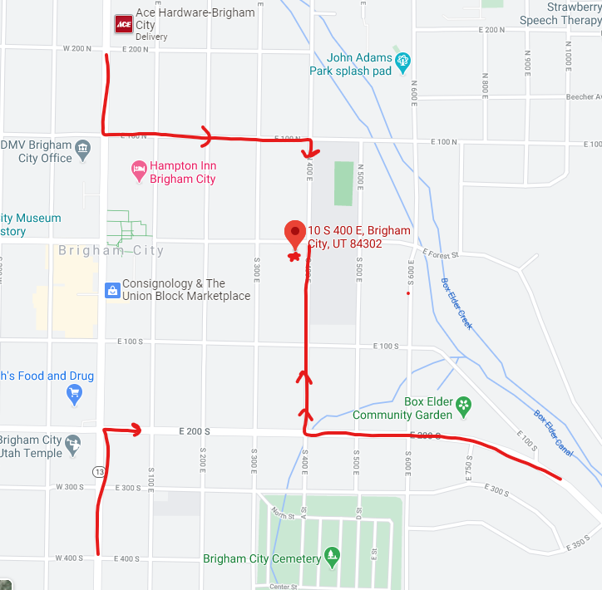

The Brigham Up to 3 office is 10 S 400 E directly West of the Middle School.

The map shows options to get there from 3 directions.