Adobe Sign Process

- Office Staff Process
  - Documents that are sent to families by SC through Adobe Sign are also shared with the office staff through email once they are signed by the family.
  - Office staff print off the Adobe Sign documents and file them in the child’s respective charts
  - The office staff also add an alert to the respective child’s BTOTS chart with what document(s) was/were received through Adobe Sign and the date that they were signed in parenthesis.
  - The adobe sign documents that were received should also be documented in the Excel tracking sheet titled “Adobe Sign Document Tracking”. This Excel sheet is stored in BOX in the “Adobe Sign Folder”
  - The PDF documents are then saved in BOX in the “Adobe Sign Folder” in a sub folder with the Child’s UP# and first initials in parenthesis
- BOX Instructions
  - All Adobe Sign files as well as the tracking spreadsheet are stored in BOX. This folder should have been shared with everyone previously, but if it hasn’t please contact the office staff to get the folder shared with you.
  - To access the Adobe Sign folder, go to https://usu.app.box.com/.
  - Sign in in with your USU username and password
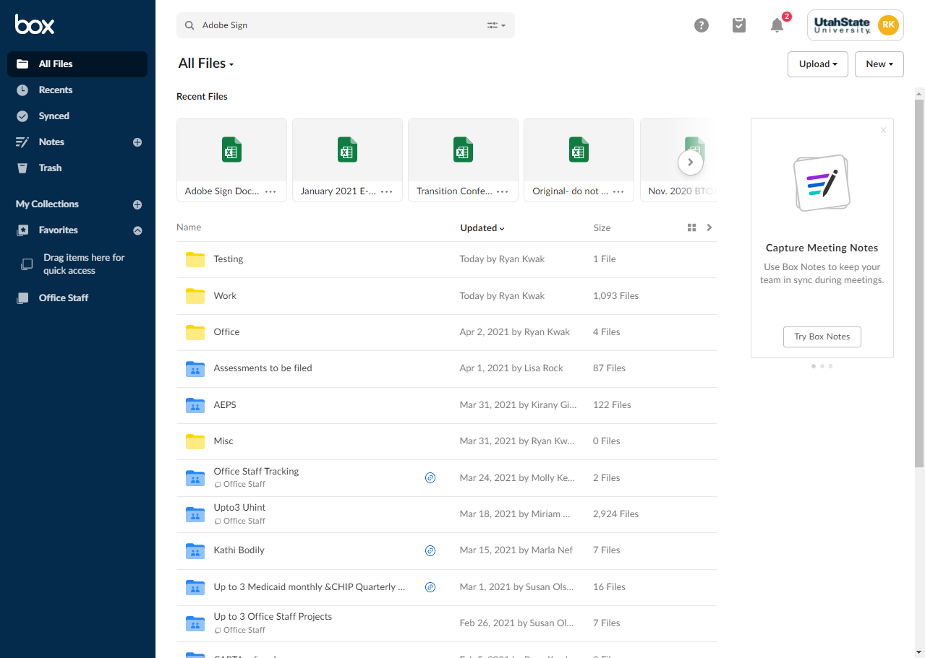
  - Once you sign in, it will bring you to your BOX home page

  - You will be able so see all of your folder/files that are stored in BOX or that have been shared with you on this home page. The folder with the Adobe Sign documents is titled “Adobe Sign Documents”. If you can’t find it on your home page you can also use the search bar at the top of your home page to find it.
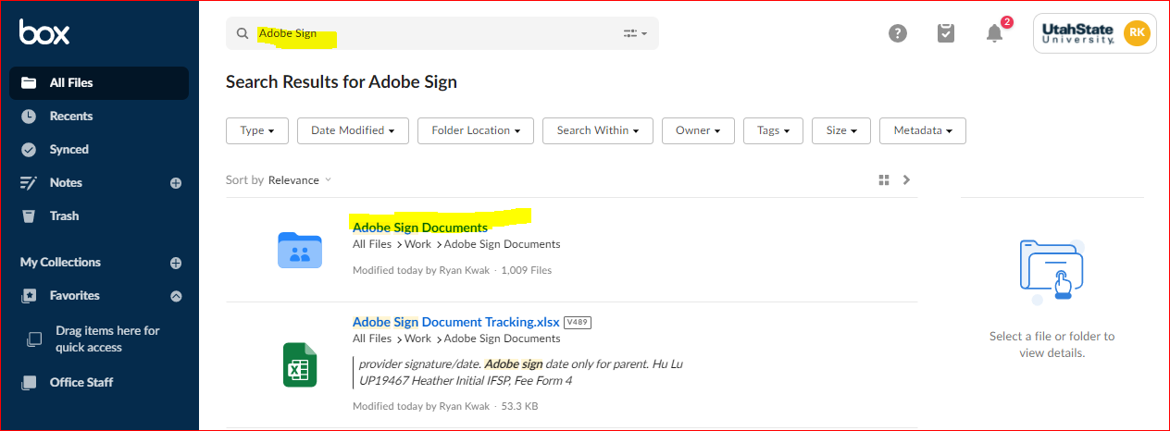

  - Once you have opened the “Adobe Sign Documents” folder you will see that there are several folders that have the child’s UP# and first initials in parenthesis. The easiest way to check which documents have been received through Adobe Sign is to enter the UP# in the search bar at the top of the Adobe Sign folder.
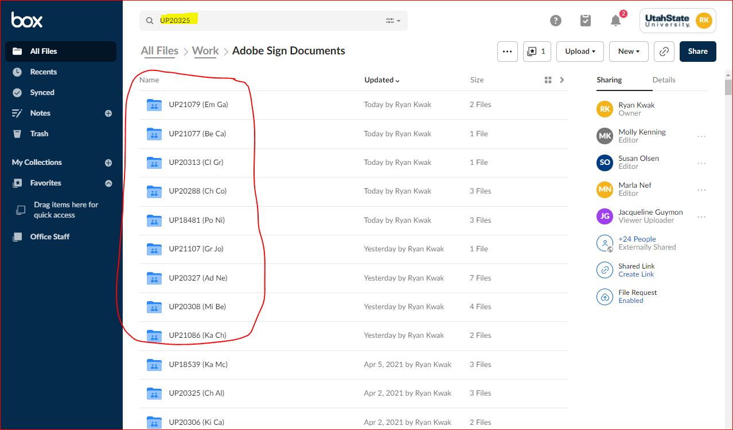

  - There is also a tracking Excel sheet that the office staff updates with all the Adobe Sign documents that have been received. This Excel sheet, titled” Adobe Sign Document Tracking”, can be found inside the “Adobe Sign Document” folder. You can also search this name in the search bar on either the BOX home screen or inside the Adobe Sign folder.
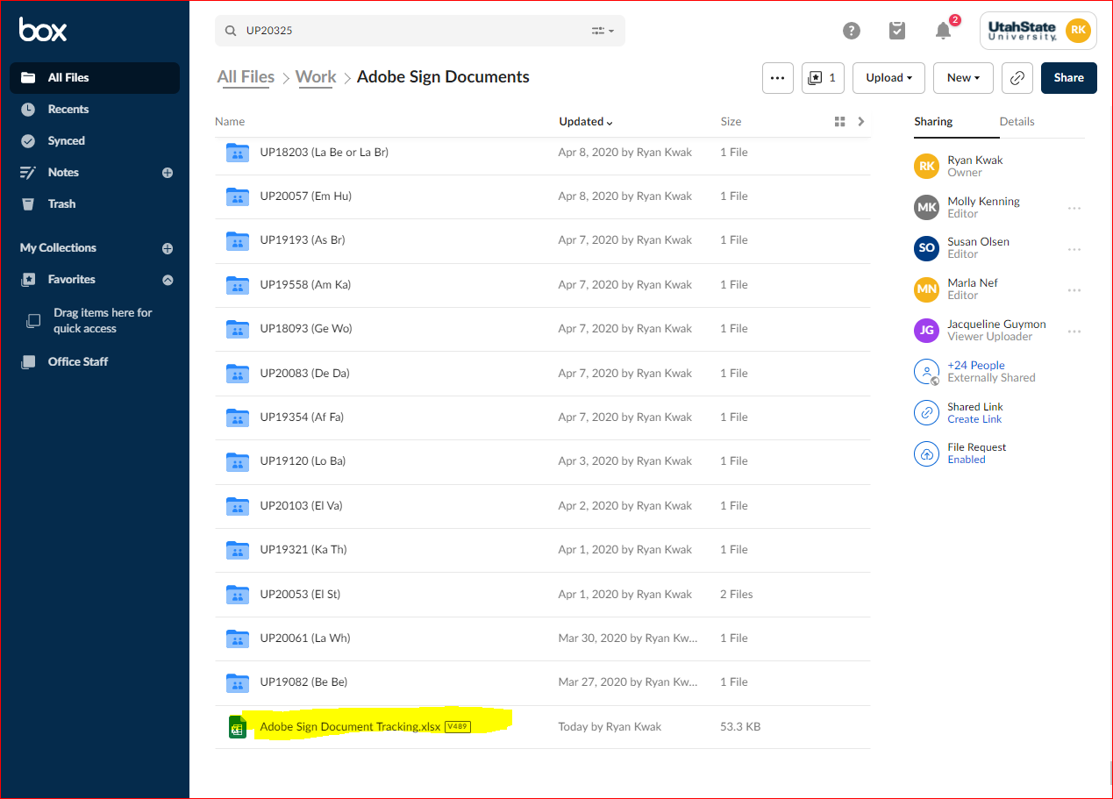

  - The Excel tracking sheet has a list of all the documents we have received in Adobe Sign. Each entry has the child’s initials, UP#, service coordinator, what document was received, and the date it was filed.

