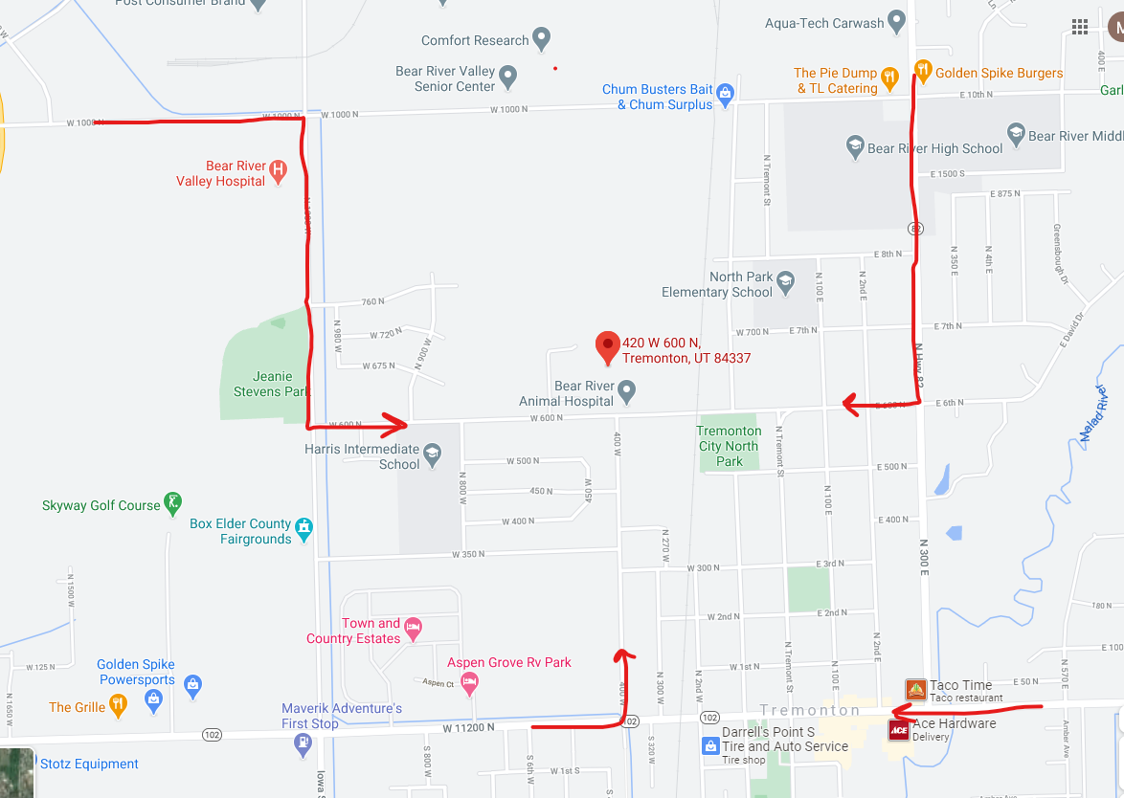

Tremonton Office: 420 W 600 N. South Entrance of USU Extension. Near Bear River Animal Hospital.