Service Coordinator Map
The service coordinator boundary map was created by the Up to 3 office staff using Google Maps to facilitate the assigning of referred children to the correct service coordinator.
The link is listed below:
https://www.google.com/maps/d/u/0/edit?mid=1-01DIeuHgQZT7NJgcgqtc2Z4TeP61Yw9&usp=sharing
Troubleshooting:
The map boundaries should be more or less accurate, however sometimes when addresses are entered into the map it will come up with a different city (as shown in the image below)

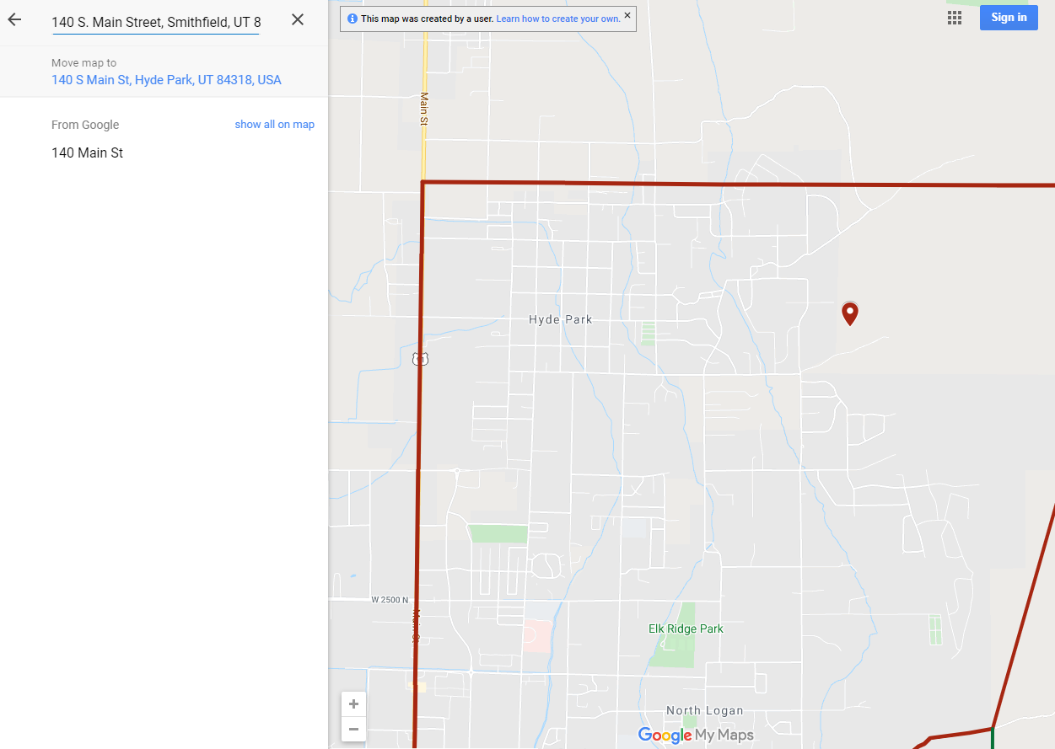
This doesn’t happen often, but if it does here is how to solve the problem. Enter the address into google and copy the address the comes up in google (as shown in the image below). The highlighted address is what should be copied.

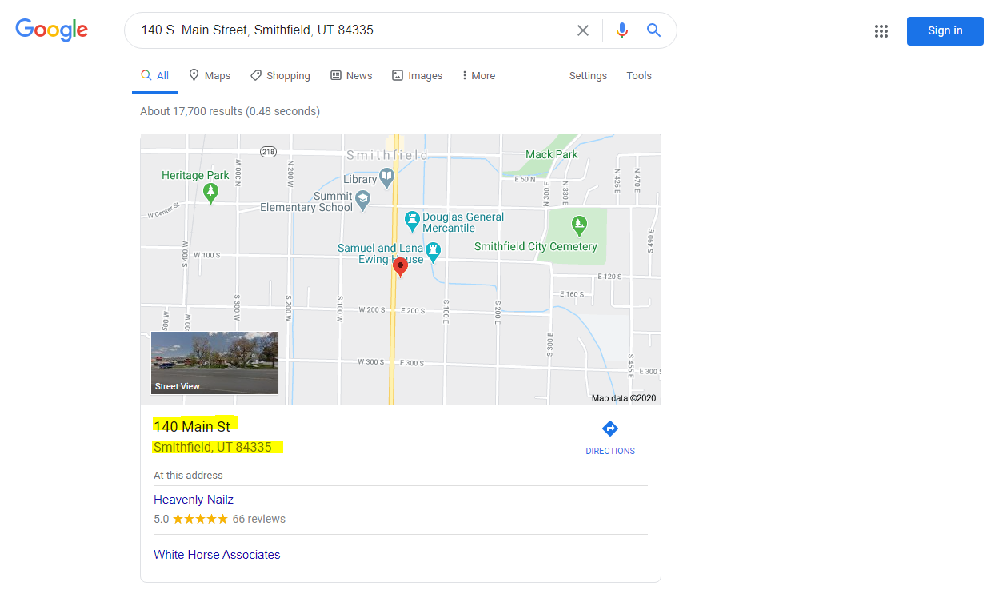

After copying this address, paste it into the SC map and the correct address should populate (as shown below)

