School District Map
The School district map was created by Cachey Valley school districts to track school district boundaries and bus stops for both Logan and Cache school districts.
The link is listed below:
http://transdata.ccsdut.org/smap.html
Best Practices for Use
When you follow the link, it will take you to a map of Cache Valley (screenshot below).
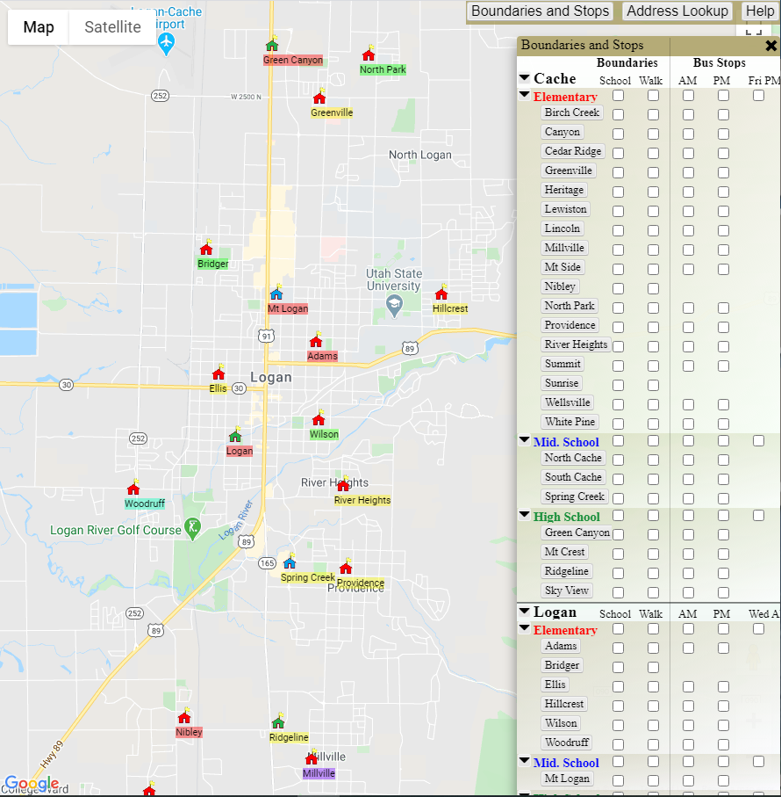
The easiest way to use this map is to select all of the Logan school district boundaries on the “Boundaries and Stop” menu on the right side of the screen. The screenshot below has the boxes that should be selected circled in red.

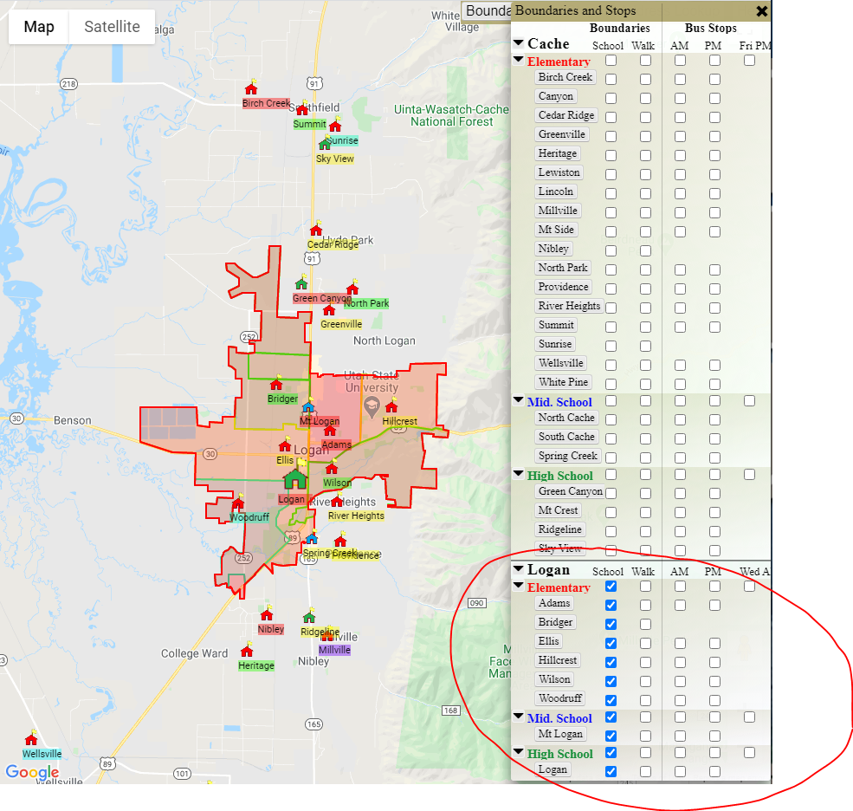

Once these are selected, the boundaries for Logan school district should appear on the map. After the Logan boundaries appear, enter an address in the “Address Lookup” menu bar in the top left corner of the screen and it will drop a pin on the map (as shown below). If the pin falls within the Logan boundary section, it is Logan school district, and if it falls outside the boundaries it is Cache school district.

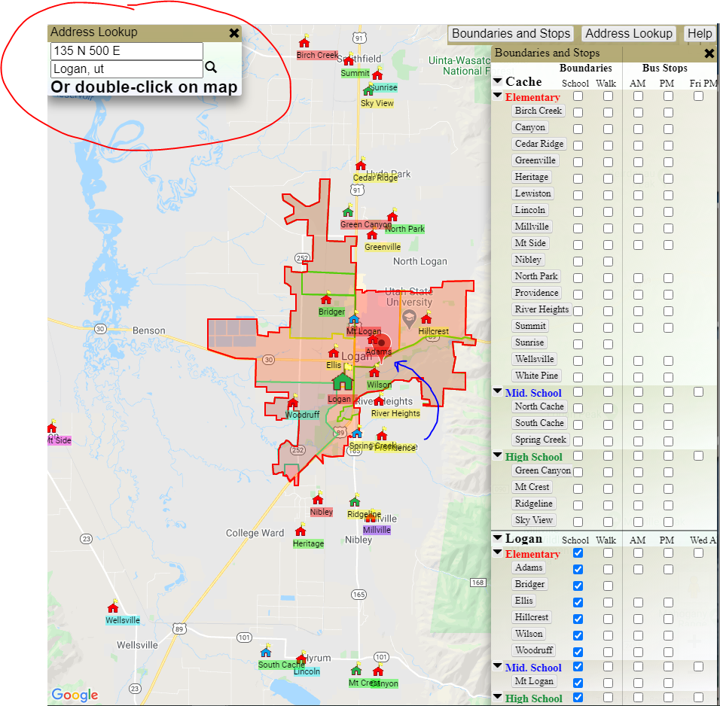

Troubleshooting
If the “Address Lookup” and/or “Boundaries and Stops” menu bars do not appear on the map, select the respective buttons for these menus that are located in the top right corner of the screen as shown below.

