Monthly IFSP Report Process
Every month on the first Tuesday, service coordinators review the upcoming six month and annual IFSP reviews that are due two months in the future (i.e in July they are looking at IFSPs that are due in September). A list of these upcoming IFSP reviews is added to the weekly referral Google spreadsheet. This report should be run before the first Tuesday staff meeting of every month or sooner if there will be a holiday on the day of the staff meeting.
- Run the BTOTS “IFSP Review Reminders” report found under the “Reminder Reports” section of the BTOTS’ report page for both six-month and annual reviews.
  - Six-Month Review
    - Select Date Range: two months in the future for the whole date range
      - If you are working on this report on 6/30/2021, you would be running these reports for a 9/1/2021-9/30/2021 date range OR If you are running this report on 7/30/2021 you would be running these reports for a 10/1/2021-10/31/2021 date range
    - Select Child Identifier: Child Name
    - Select Report Type: Six-Month Review
    - Groupe By: Service Coordinator
    - Sort Report By: Sort by Child Name
    - Exclude Completed Reviews: Yes
  - Annual Review
    - Select Date Range: two months in the future for the whole date range
      - If you are working on this report on 6/30/2021, you would be running these reports for a 9/1/2021-9/30/2021 date range OR If you are running this report on 7/30/2021 you would be running these reports for a 10/1/2021-10/31/2021 date range
    - Select Child Identifier: Child Name
    - Select Report Type: Annual Review
    - Groupe By: Service Coordinator
    - Sort Report By: Sort by Child Name
    - Exclude Completed Reviews: Yes
- Go to the new intake Google spreadsheet
- Create a new tab for the new month’s six-month and annual reviews
  - i.e “October 6mo/annuals”
- Copy and paste the table found in the “Template for 6 mo/annual Report” OR copy and paste the data from the previous month and clear all the old data
- Use the BTOTS reports to fill in the six-month and the annual review sections of the table for each service coordinator. You may need to go to the child’s BTOTS chart to get more of the information needed but you can click on each child’s name on the report to quickly open up the child’s chart
  - Note: When opening up a child’s BTOTS chart using the report, it’s easier to right click on the child’s name and select “Open link in new tab” because left clicking on the link will open up the child’s chart over the report and you will have to re-run the report
- Table information
    - Child’s initials
    - Up#
    - City
    - Age (in months)
    - Team members
      - Use the team information found on the report to input the first name of the therapist who needs to participate in the IFSP review
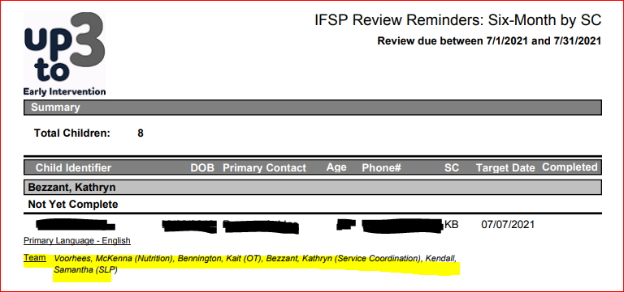

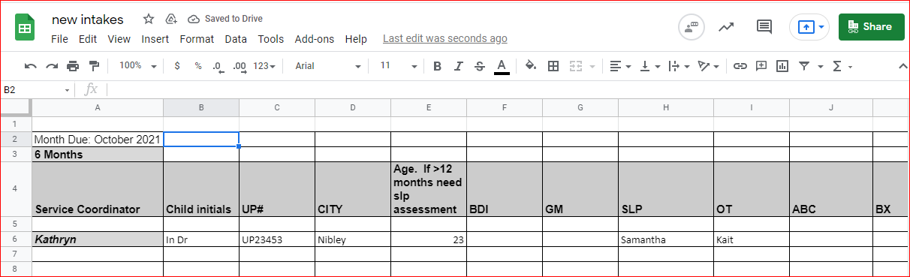

- Do this for every child found on both the six-month and annual report for the given month

