- Go to usu.app.box.com and sign in with your A number and Password
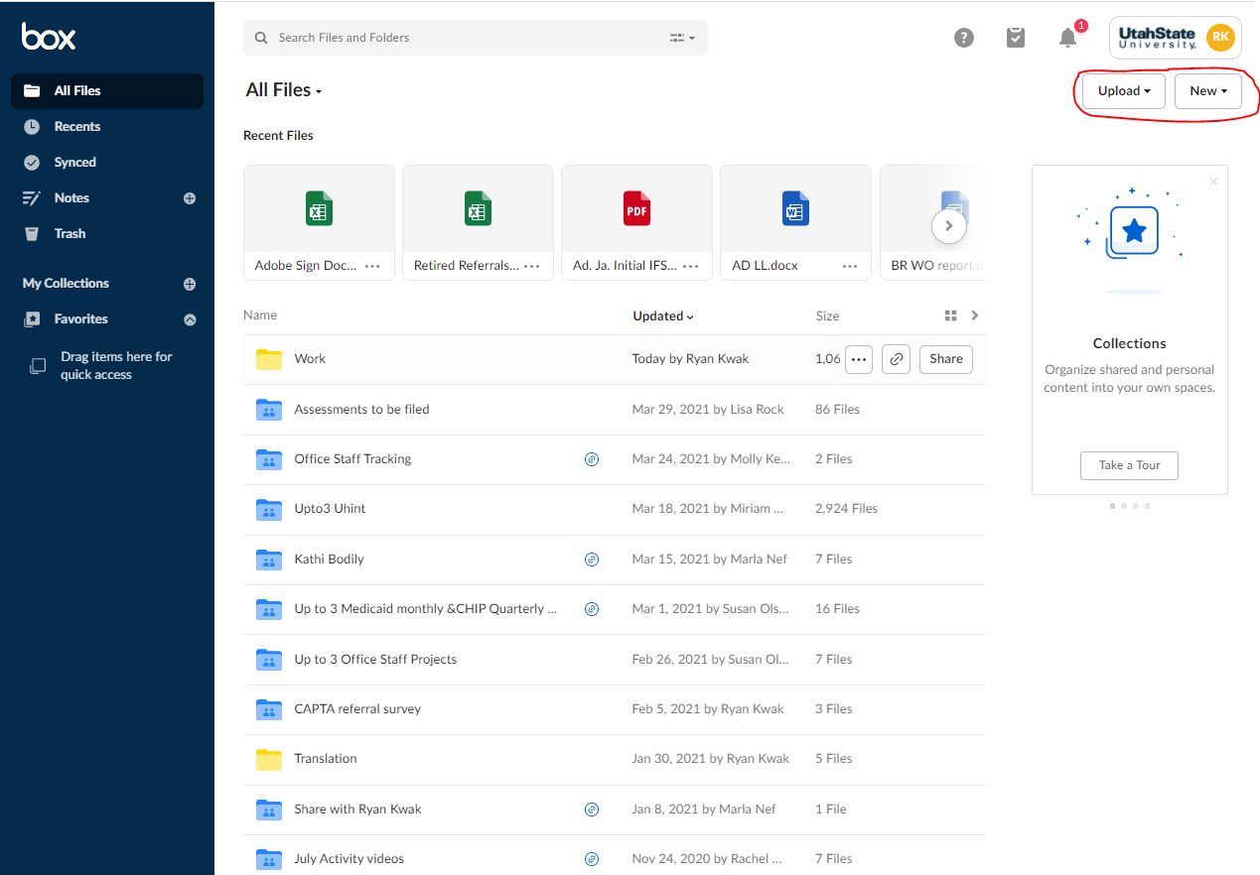
- Home Page

  - When you sign in it will take you to the home page. All your folders/documents will be shown in the middle (Yellow folders are personal folders that aren’t shared with anyone. Blue folders are folders that have been shared with at least one other person)
  - You can access any of your personal/shared files or folders from this home page. You can also search files and folders at the top of the screen
- Uploading Files/Creating Folders
  - At the top right of the screen you’ll an “Upload” and “New” button. If you want to upload a specific file/folder from your computer, select the upload button and either the file or folder option and it will let you attach something from your computer.
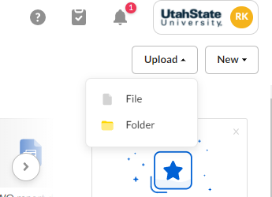

  - If you want to create a new folder directly in BOX or a word/excel/PowerPoint directly in BOX select the “New” button and select the appropriate option.
    - 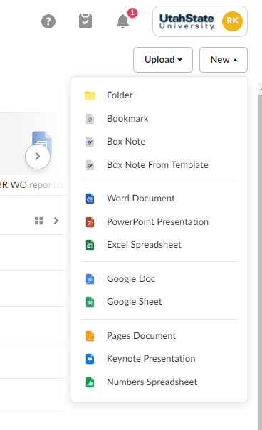
    - Note: Word documents, excel sheets, PowerPoints etc. that are opened/created directly in BOX will open the web version which will allow multiple people to edit the same document simultaneously (similar to Google Docs).
  - If you select “New” “Folder”, it will bring up a window where you can name the folder and invite anyone else to access the contents. If you want to share the folder, you can just type in the person’s name and it should come up with some options or you can just add their USU email.
    - 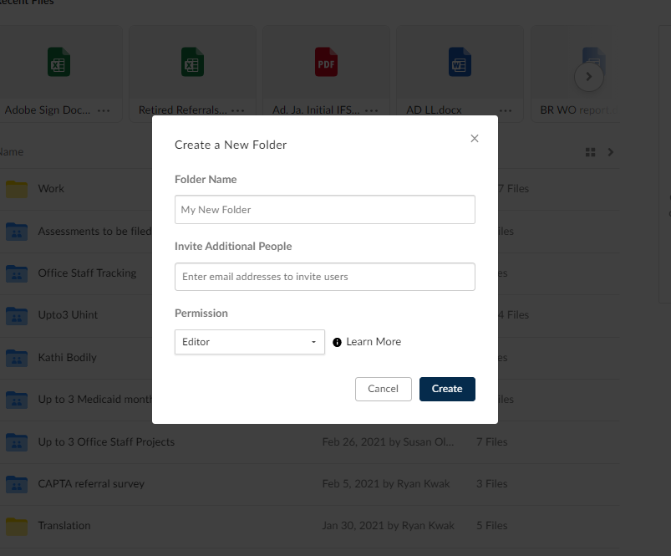
  - Once you have created a new folder, it will appear on your home screen and you can select it to open it up. When you have opened the folder, you will see the “Upload” and “New” options still on the top right of the screen. If you want to upload files/create new folders inside of the new folder you can use these options to do so (just like before). You can also click and drag files from your computer directly into the folder.
    - 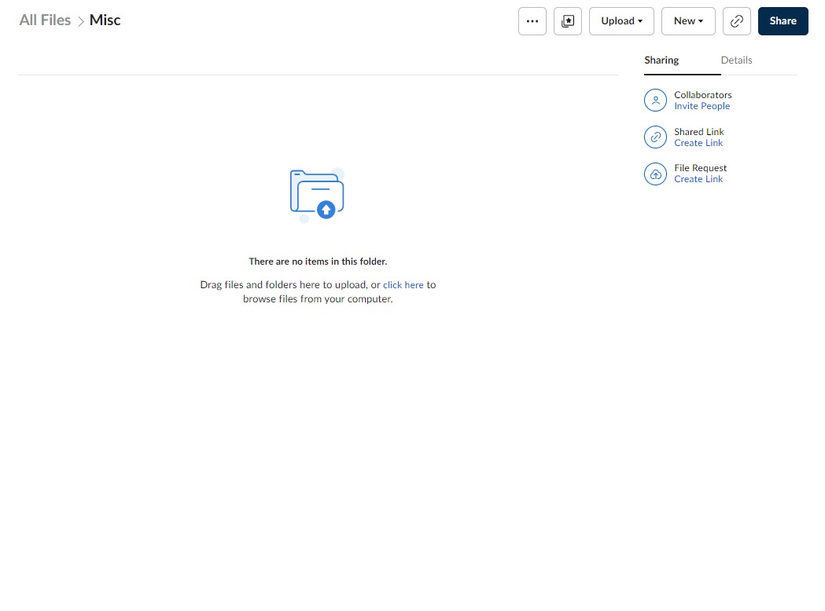
  - If you click the blue “Share” button that is also on the top right of the screen you can share it with additional people. Everyone who you have shared the folder with will appear on the right side of the screen (inside the folder).
    - 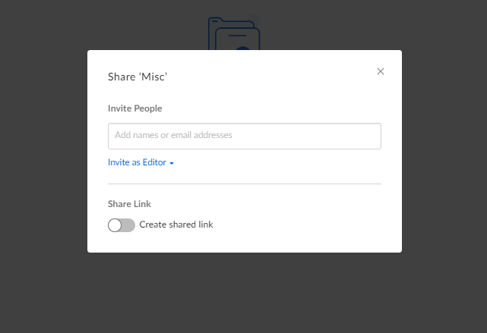

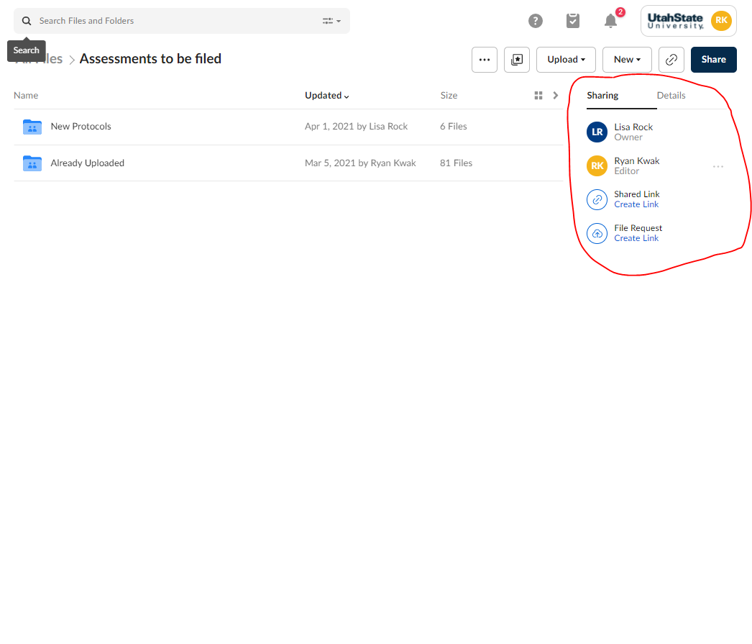

- Accessing files/folders that have been shared with you
  - After sharing a folder/file with someone, they will get an email explaining that you have shared a file with them
  - 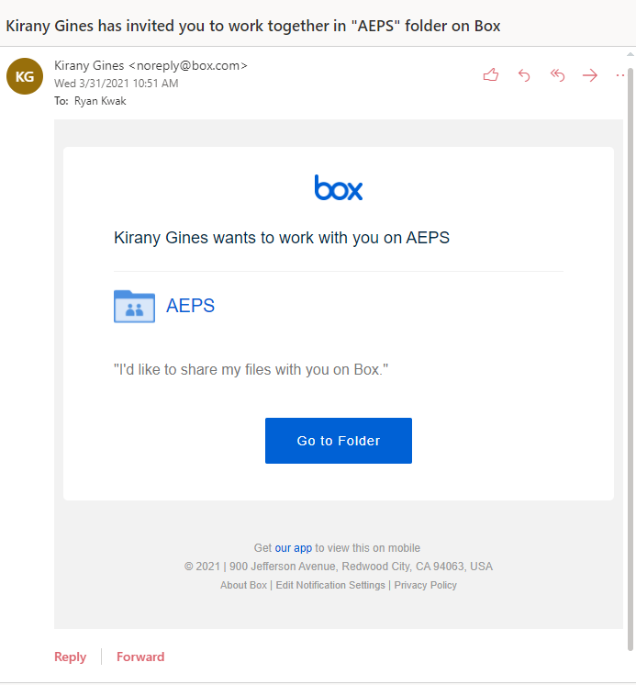
  - The person receiving this email can either use the “Go to Folder” link to go to this shared folder (they will have to log in to BOX if they aren’t already signed in) or this shared file/folder will also appear on their home page or they will be able to search it on their home page.
- Box Features
  - If you right click a file (or if you select the three dots to the right of the file name if you hover your mouse over it) it will bring up a drop-down menu with different options of different things you can do with the documents (such as download, uploading a new version of the document from your computer, or sharing)
  - 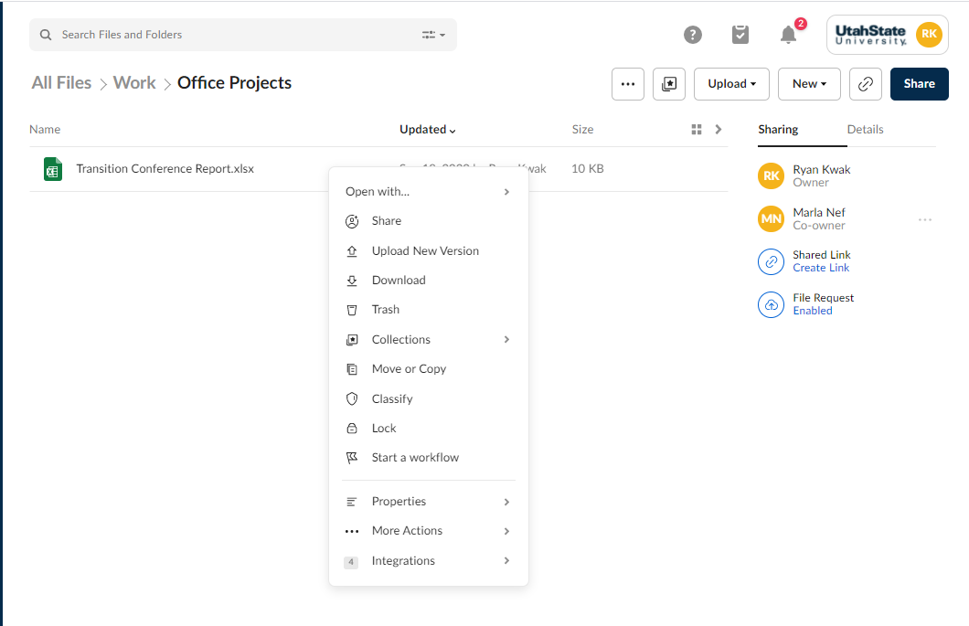
  - You can rename any folder or document by selecting the pencil icon that will appear next to the name if you hover over the file name
  - 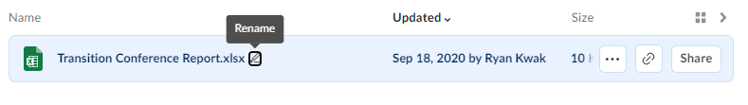
  - 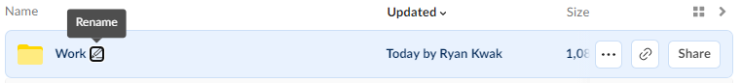
- Collections/Favorites
  - You can create collections in BOX which are basically folders where you can organize any personal or shared files. These collections are just for you own personal organization so even if it’s a shared folder/file you are the only one able to view your collection.
  - There will also be a “Favorites” section where you can drag folders/files you access often
  - Your collections will appear on the left-hand side of your BOX home page (in the blue section).

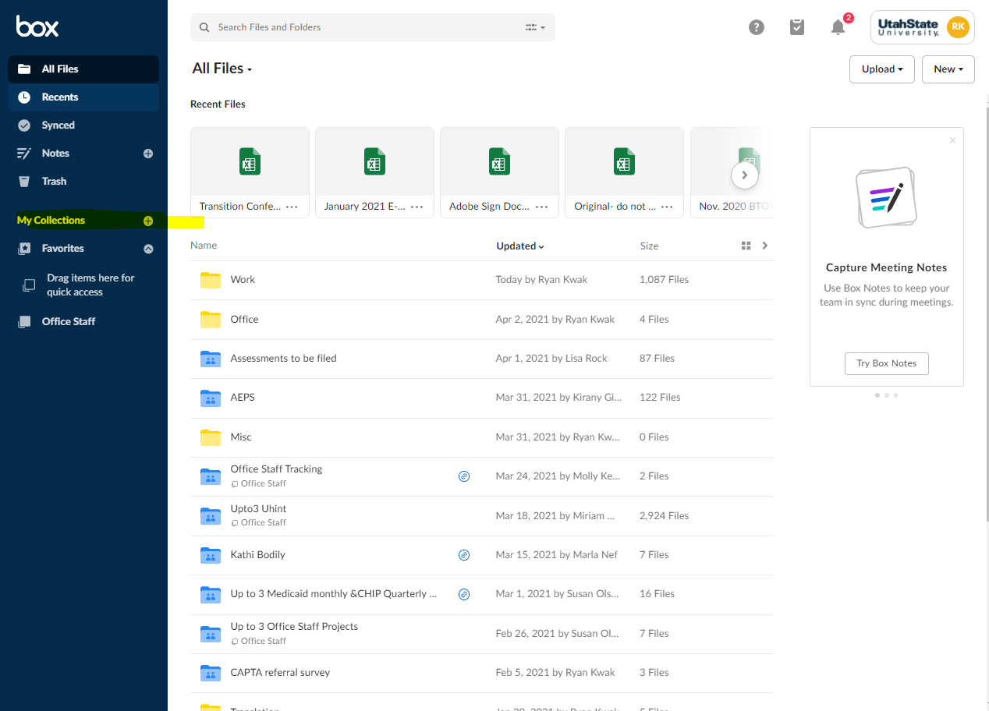

  - To create a collection, just click the plus sign that’s to the right of the “My Collections” button on the left side of your home page. It will bring up a window where you can name your new collection. It will then appear on the left side of the screen.
  - Once your collection is created, you can click on it to access the contents as shown below. Each document/folder inside the collection will have the name of the folder underneath the name where it is actually stored.
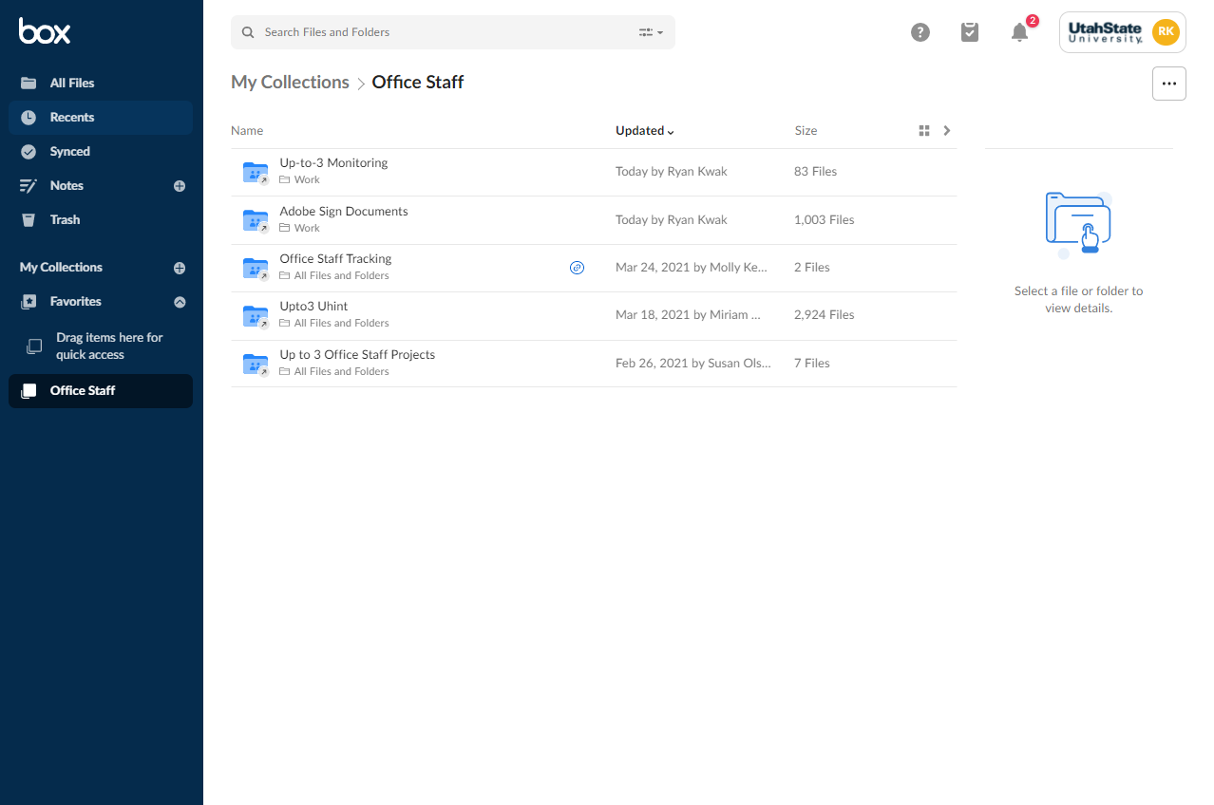
- Adding files to Favorites/Collection
  - You can add items to your Favorite/Collection side bar in two ways
  - The first way is just clicking and dragging any folder/file into the collection folder from the home page. You can also click and drag any folder/file to your “Favorite” section.
  - The second way is left click over a specific file/folder and select collections in the drop-down menu. It will come up with all your collections and you can add it to the collection.
