Deactivating in Well Sky
- Complete this report on the last day of every month.
- Run the “Exited Children” report for the given month range.
  - In BTOTS, select the “Reports” tab near the top right of the screen
  - The “Exited Children” report is under the “Exit Report” section
    - Select the given month range (i.e 7/1/2021 to 7/31/2021)
    - Group By: None
    - Select Age Range: All
    - Select Child Identifier: Child Name
- Deactivate every kid on the “Exited Children” report in Well Sky.
  - Log in to Well Sky
  - Start typing the last name of each kid anywhere on the Well Sky page and a “Patient Search” window will populate on the screen allowing you to search for any current or deactivated child
    - Note: Well Sky’s search function is very sensitive. You have to enter the name exactly as it’s written in Well Sky or it won’t find the child.
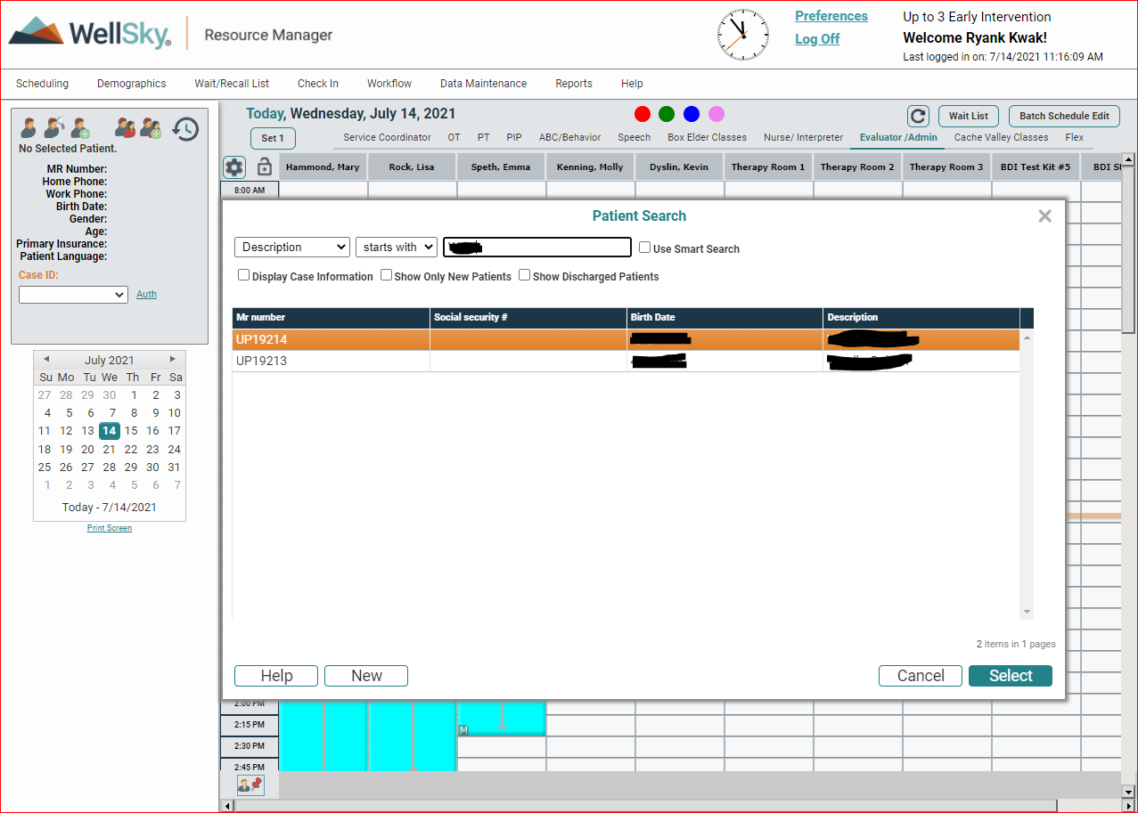

  - Once you have typed in the last name for the specific child in the patient search window it will populate with possible options underneath. Click on the appropriate child and push “Select” at the bottom right of the window.
    - Note: Double check to make sure the child you have selected is the appropriate child with the same first and last name, birthdate, and UP#
  - After selecting a child on the patient select menu, their information will appear in the grey box near the top left of the screen. Click on the toolbox icon that is located on the far left of the grey patient information box
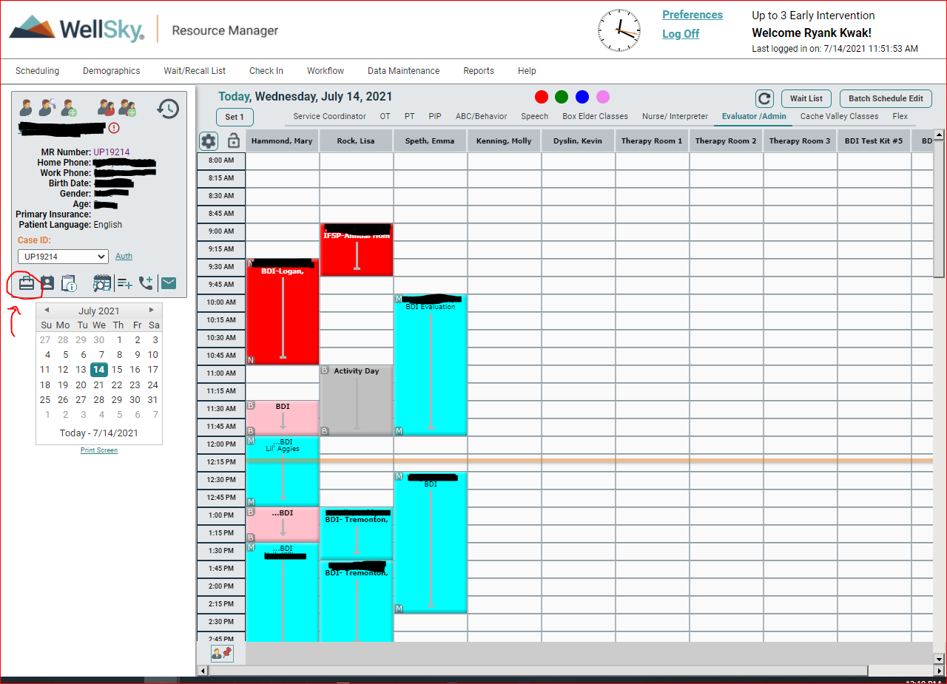

  - After clicking on the toolbox icon, you’ll be taken to the “Resource Manager” screen. From here, click the “Edit” button next to “Wait List History”.
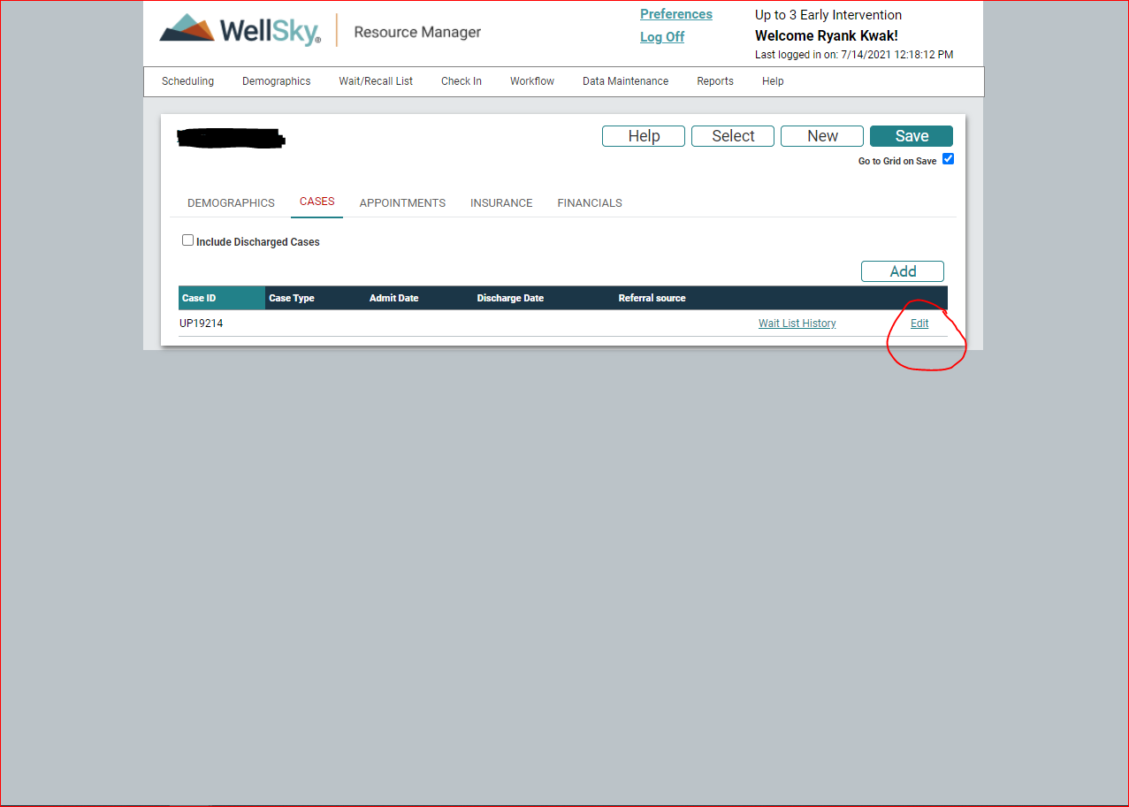
  - The edit button will bring up the “Editing Case” window for the child.
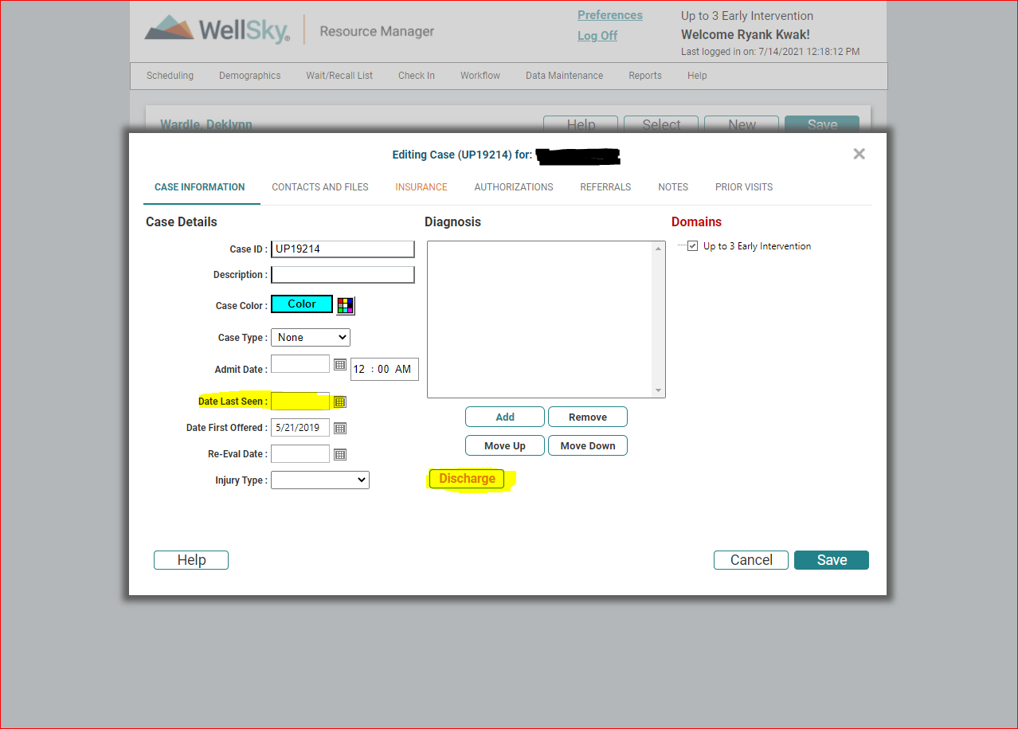
    - On this screen, put the exit date that is found on the exit report in “Date Last Seen”

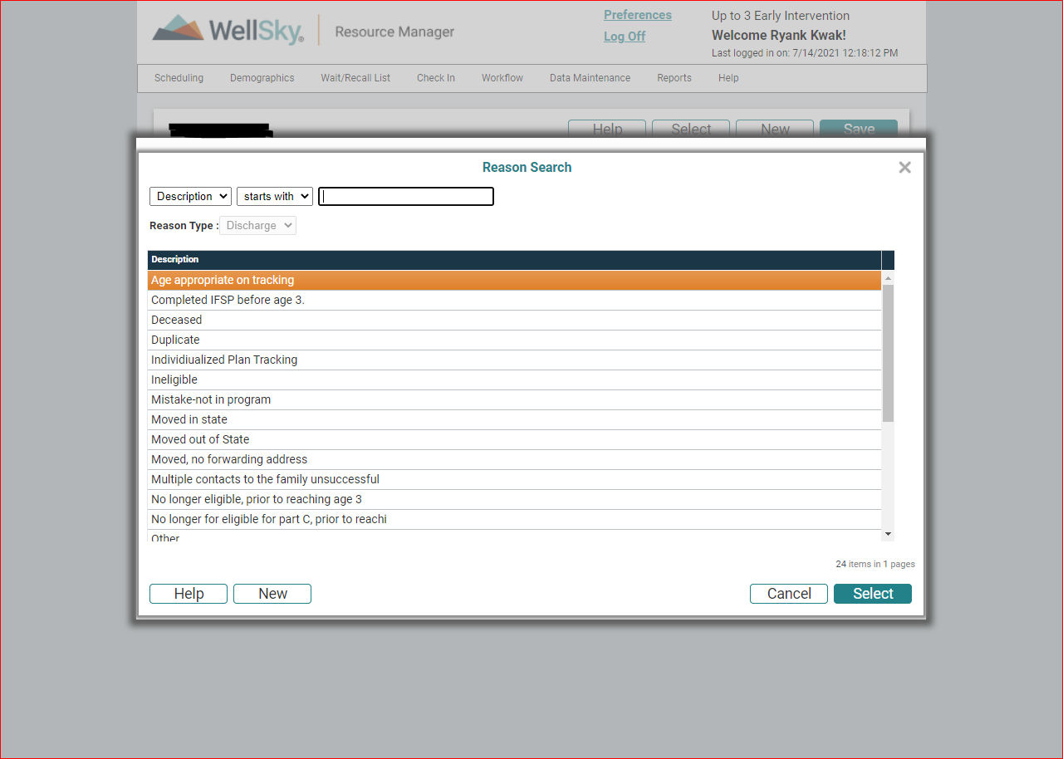
    - Afterward, select the “Discharge” button which will bring up the “Reason Search” menu with different exit reasons. Select the exit reason on Well Sky that best matches the exit reason listed on the exit report.

    - After entering the exit date and exit reason into Well Sky, select “Save” to finish exiting the child.
  - Repeat steps for each child found on the exit report.
  - Run the exit report for both the current month and the previous month
    - Service coordinators will sometimes exit children from the previous month later in the next month. The best practice is to run the exit report for both the current month and the previous month.
    - Use the exit report from the current month to deactivate all children found on the list from Well Sky
    - Use the exit report from the previous month to check for any additional children who were exited after the exit report was initially used
      - The easiest way to check to see who has been deactivated already is to type the last name of every child on the exit report from the previous month into Well Sky.
      - The patient search menu in Well Sky defaults to only showing active children. Any child who has already been deactivated will not show up on the patient search menu. Go through the previous month’s exit report and deactivate every child who shows up on patient search menu and ignore the children who don’t populate on this menu as they would have already been deactivated.

Folder Exiting
Service coordinators pull the folders for their exited children every month and give them to the office staff member responsible for exiting.
- Folders in a blue, red, or green folder
  - Pull the permanent (manila) file from the rotating cabinet by conference room 205 for each child
  - Move everything from the working chart to the permanent file based on section (procedural safeguards/IFSP/Assessments/Visit notes/Medical Records)
    - Procedural safeguards: prior notices, consent forms, CHARM, release of records
    - IFSP: IFSPs (six-month, initial, annual), transition (transition steps 1-5, transition conference, school district release)
    - Assessments: Protocols for BDI, AEPS etc.
    - Visit notes: Any paper visit notes
    - Medical Records: Medical records from hospital
  - The “Access Monitor for Client Records” form should be placed on the top of the left side
  - Peel the label off the checkout sheet if there are still available checkout slots. Shred the checkout sheet if it is completely used.
  - Peel the label off the working file and shred the paperwork in the clear front pocket. If the empty working folder is in good condition, save for future use. If it is badly damaged, recycle the folder.
  - File the perm (manila) folder in alphabetical order in the perm filing cabinets for the current year (between Marla and Sue’s office).
- Folders already in a permanent (manila) file—after Summer 2020 all new files for incoming children in our program were placed solely in a permanent file instead of a working file.
  - Organize the child’s perm file if necessary by checking to see that everything is in its appropriate place (i.e. IFSPs are in the IFSP section, assessments in the assessment sect etc.) and securing any loose papers in their appropriate section
    - Procedural safeguards: prior notices, consent forms, CHARM, release of records
    - IFSP: IFSPs (six-month, initial, annual), transition (transition steps 1-5, transition conference, school district release)
    - Assessments: Protocols for BDI, AEPS etc.
    - Visit notes: Any paper visit notes
    - Medical Records: Medical records from hospital
  - Pull the “Access Monitor for Client Records” form from the back of the procedural safeguard section to the top of the left-hand side of the folder
    - If there is not one of these forms already in the chart, place a new one on the top of the left-hand side
  - Peel the label off the checkout sheet if there are still available checkout slots. Shred the checkout sheet if it is completely used.
  - File the perm (manila) folder in alphabetical order in the perm filing cabinets for the current year (between Marla and Sue’s office).

