How to Create New Charts for New Referrals
Overview of Steps
- Print four labels for each kiddo (three for the chart, one for the checkout sheet)
- Create folder with dividers and current referral year sticker (if there are no extras)
- Create checkout sheets for each kiddo (if there are no extras)
- Place a letter sticker on the folder corresponding to child’s last name
- Place the referral sheets and ASQ in their corresponding spots in the chart
- File each chart alphabetically in the working file cabinets with the checkout sheets

Details
- Labels
  - Open a new word document
  - Enter the “Mailings” tab at the top and select Labels
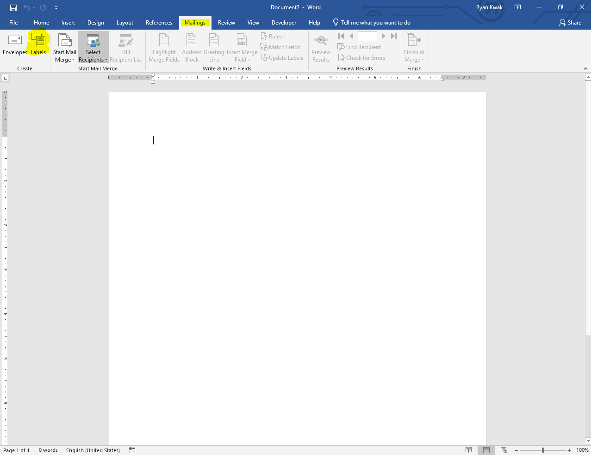
  - Once you’ve selected Labels an additional window will populate. To select the correct labels, select options which will bring up another window (Label Options) make sure that under the “Printer Information” section that “Page printers” is selected and that “Multi-purpose Tray” is selected in the Tray drop down menu beside it. In the Label vendors section (under Label information) select “Other/Custom”. Once this is selected, there are some options that will appear in the Product number section below it. Select “8066 Removable filing labels”. 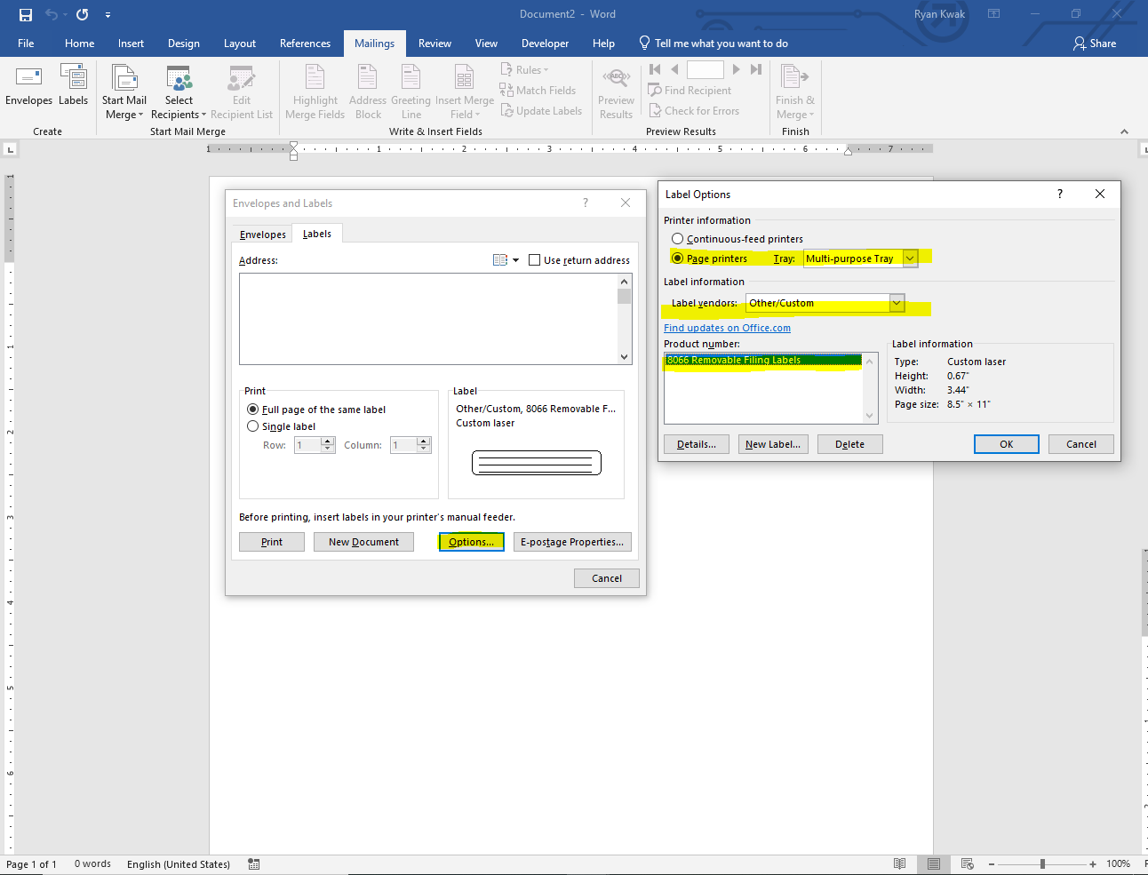
  - After selecting this, press okay and then select “New Document” back on the original window.
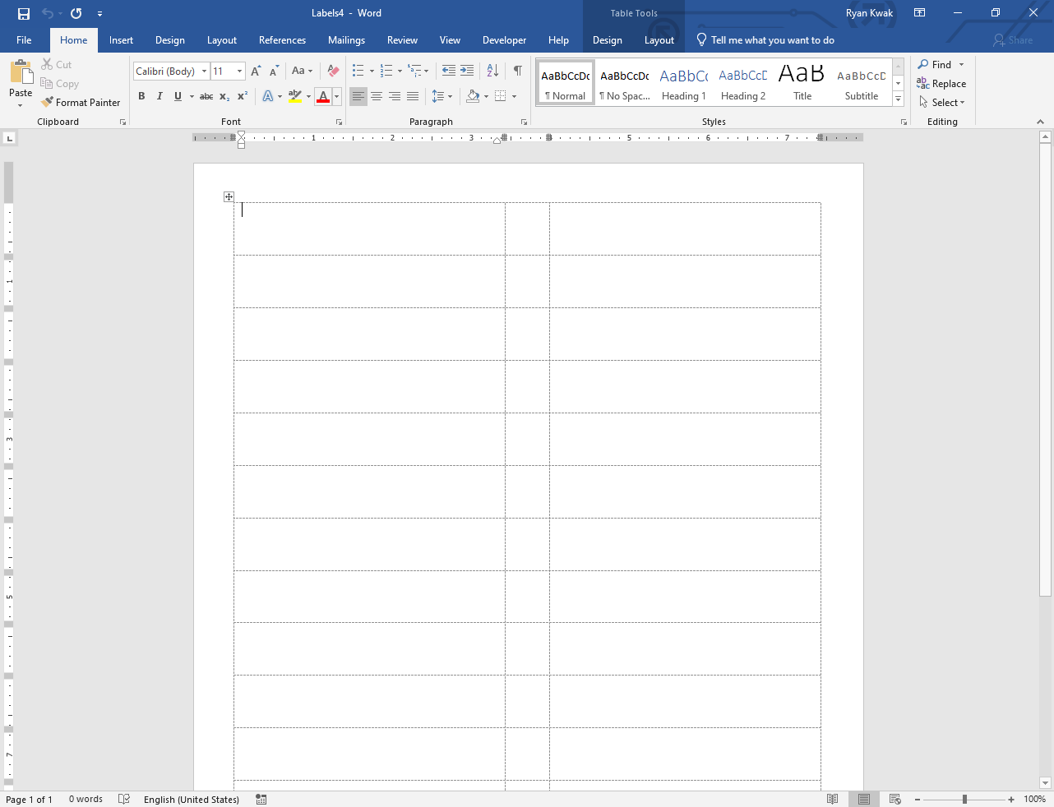
  - There should be four labels per kiddo. Two of the labels should have the child’s last name, first name and UP#. The other two labels should just have the last name and first name. They should be done with the default font (Calibri), 18 pt. font, all letters should be capitalized and bolded.
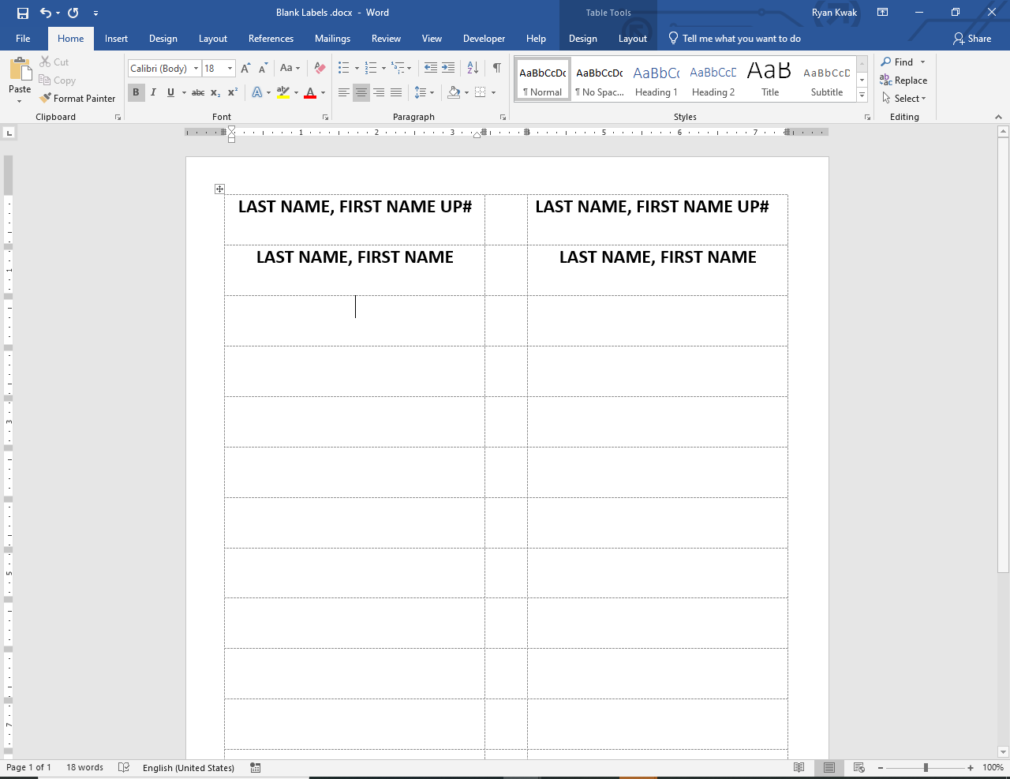
  - To print the labels off, use the label sheets provided by inserting them into the tray that opens up on the front of the Up to 3 East printer. Make sure to insert the labels correctly using the guide area on the sheets.
- Folders
  - Each kiddo needs to have a physical chart created for them using the manila folders provided.
  - On the manila folder, place a current year sticker in the bottom right corner
  - Place three of the child name labels on the folder (see example folder for placement)
  - Place an alphabet sticker corresponding to first initial of last name on the folder (see example folder for placement)
  - There are five dividers that are placed inside the folder: “Procedural Safeguards”, “Assessment”, “Medical”, “Visit Note”, and “IFSP”
    - Make copies of these if there are no extras
  - On the inside of the folder place the “Procedural Safeguard” then the “Assessment” (in that order) dividers on the left side
  - Place the “Medical”, “Visit Note”, and “IFSP” dividers on the right side (in that order)
  - File the referral paperwork inside the chart
    - The BTOTS referral sheet and hand-written form are placed under the “Procedural Safeguard” divider
    - The ASQ and ASQSE are placed under the “Assessment” divider
    - Any medical records are placed under the “Medical” divider
    - Additionally, a “Access Monitor for Client Records” form should be placed on the very bottom of the left side of the chart (under Procedural Safeguards)
- Create the checkout sheet
  - Each file, should also have a checkout sheet with the fourth label on it (Last name, first name)
  - Make copies of the checkout sheets if there are no extras
- File new charts with the checkout sheets alphabetically in the working file cabinets

**If we are running low on label sheets, manila folders, alphabet stickers, or year stickers please let Miriam know, so that she can order more**

