Adobe Sign Process
- Office Staff Process
  - Documents that are sent to families by SC through Adobe Sign are also shared with the office staff through email once they are signed by the family. Service coordinators will cc the office staff member responsible for managing the Adobe Sign documents.
  - A copy of the document will be sent to the office staff member once it has been signed by the parent.
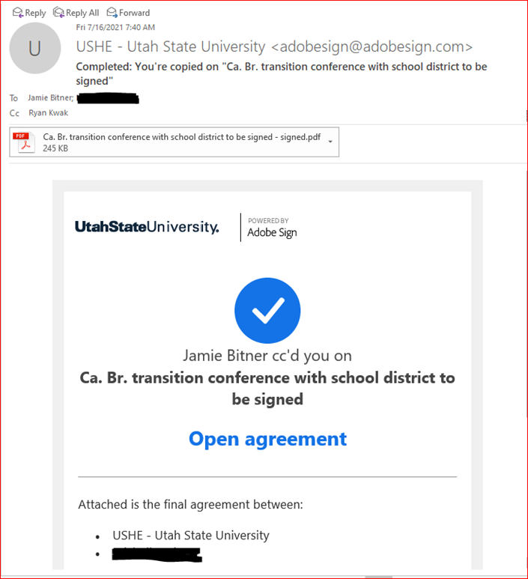

  - Download the Adobe Sign document from the email to your computer
  - The office staff also add an alert to the respective child’s BTOTS chart with what document(s) was/were received through Adobe Sign and the date that they were signed in parenthesis.
    - Documents received through Adobe Sign: “Annual IFSP (6/30/2021)” or “Doctor release to Dr. Rogers (7/1/2021)”
    - If a child is already exited in our program, document the Adobe Sign documents in the exit notes
      - Go to the “Child” tab in the BTOTS chart and then to the “Activation” sub-tab
      - Click edit next to the notes and add the Adobe Sign alert to the exit notes underneath the existing exit notes (DO NOT delete or change any existing exit notes)
      - 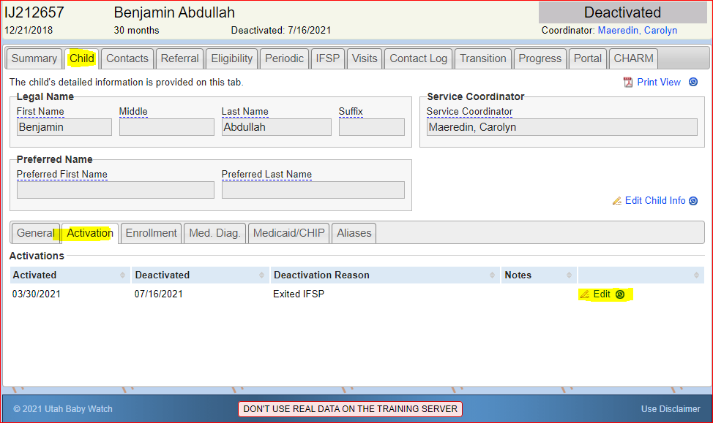
      - 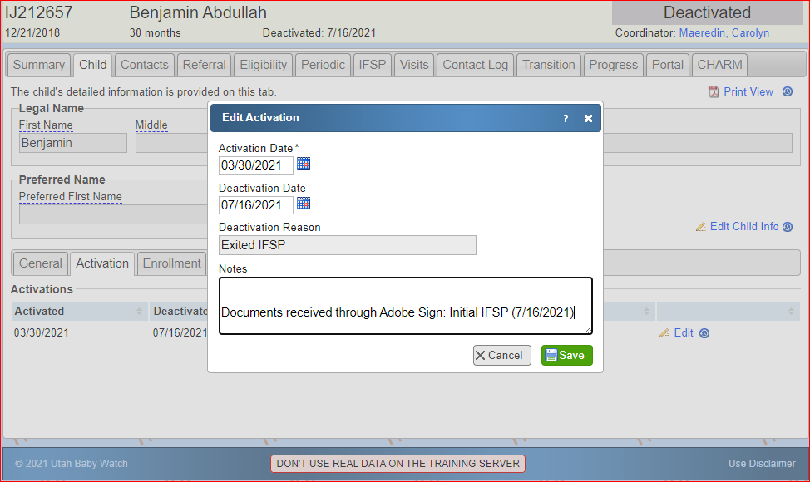
  - Move the Adobe Sign PDF into a folder in the “Adobe Sign Documents” folder on Box (additional instructions below).
    - Each PDF should be organized into a folder with the child’s UP# and first initials in parenthesis i.e UP22345 (Gr Mo)
    - Check to see if there is already an existing folder for the child before creating a new one
  - Print off the Adobe Sign documents and file them in the child’s respective charts
    - Any Adobe Sign document for a Brigham City child should be placed in the Brigham City service coordinator’s box (currently Heather Mitchell)
  - The adobe sign documents that were received should also be documented in the Excel tracking sheet titled “Adobe Sign Document Tracking”. This Excel sheet is stored in BOX in the “Adobe Sign Folder”
    - Document child initials, UP#, Service Coordinator, type of document, and the date the file was printed and filed
    - Check the document for any errors and document them in the Notes section of the Excel sheet
      - Errors can include missing signature or wrong dates (such as the document is dated in the future or March 33rd)
      - If the child is already exited from our program document this in the note section
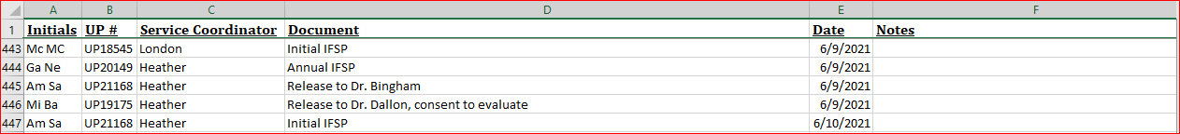

  - Delete the Adobe Sign PDF file on your computer
- BOX Instructions
  - All Adobe Sign files as well as the tracking spreadsheet are stored in BOX. If this folder has not been shared with you, contact office staff
  - To access the Adobe Sign folder, go to https://usu.app.box.com/.
  - Sign in in with your USU username and password
  - Once you sign in, it will bring you to your BOX home page

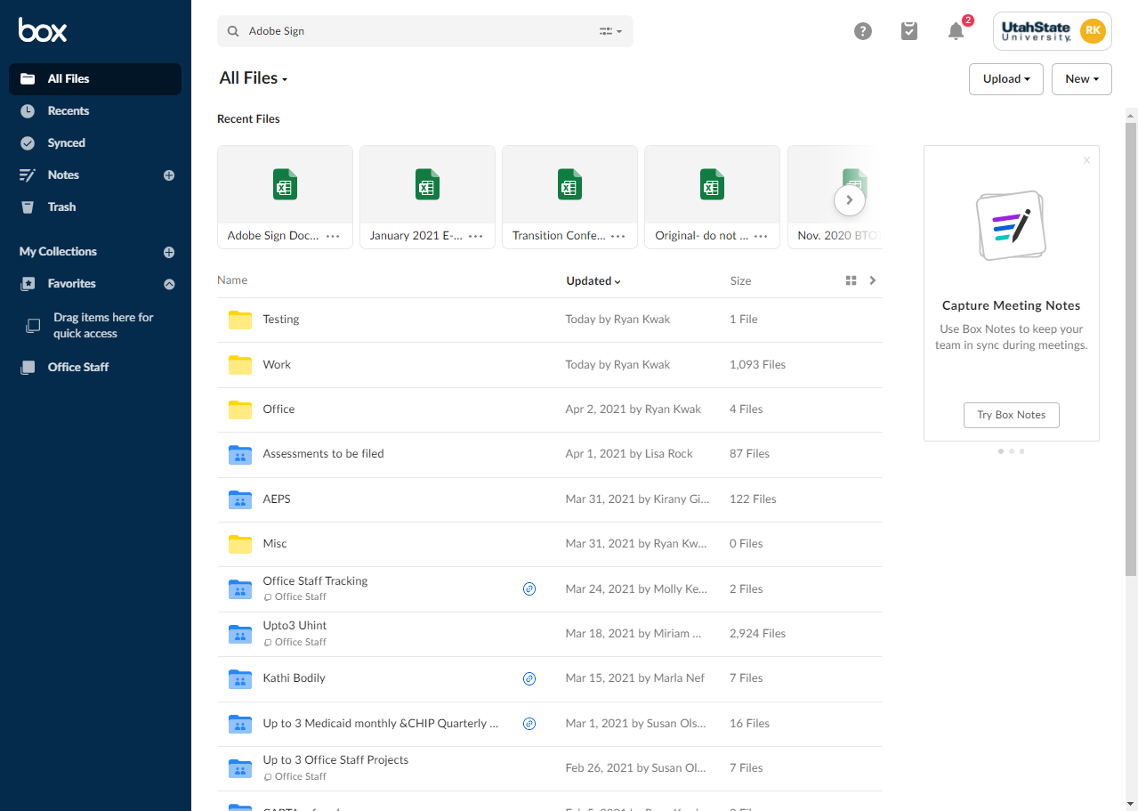

  - You will be able so see all of your folder/files that are stored in BOX or that have been shared with you on this home page. The folder with the Adobe Sign documents is titled “Adobe Sign Documents”. If you can’t find it on your home page you can also use the search bar at the top of your home page to find it.
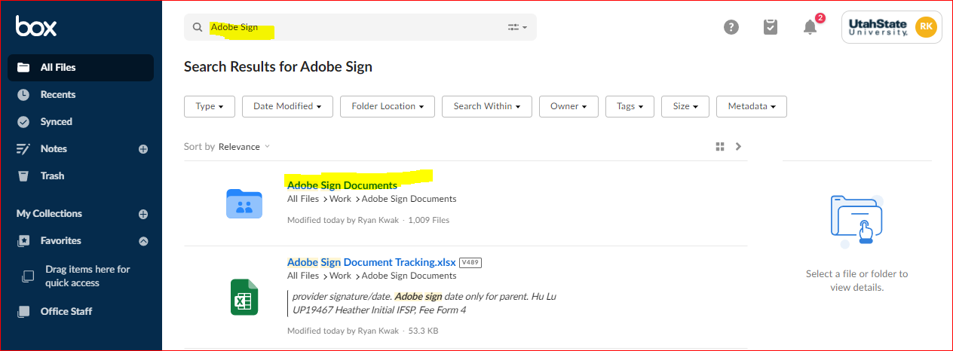

  - Once you have opened the “Adobe Sign Documents” folder you will see that there are several folders that have the child’s UP# and first initials in parenthesis.
    - The easiest way to check which documents have been received through Adobe Sign is to enter the UP# in the search bar at the top of the Adobe Sign folder.
    - Before creating a new folder in which to store the Adobe Sign PDF, check to see if there is an existing folder for the child by typing in their UP# in the search bar. If there is already a folder for this child, store the PDF in the existing folder.

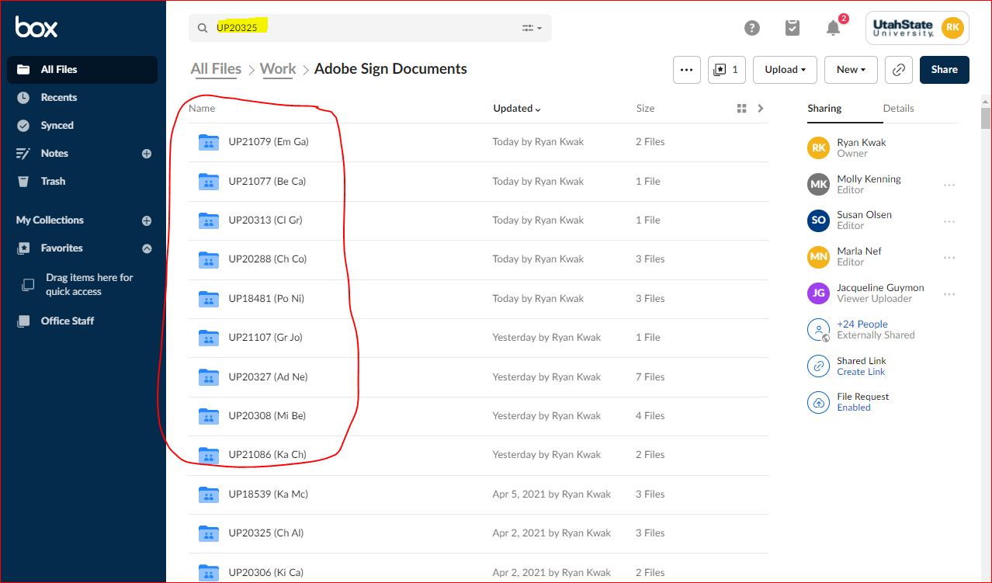

  - There is also an Excel sheet for tracking that should be updated with all the Adobe Sign documents that have been received. This Excel sheet, titled” Adobe Sign Document Tracking”, and can be found inside the “Adobe Sign Document” folder. You can also search this name in the search bar on either the BOX home screen or inside the Adobe Sign folder.

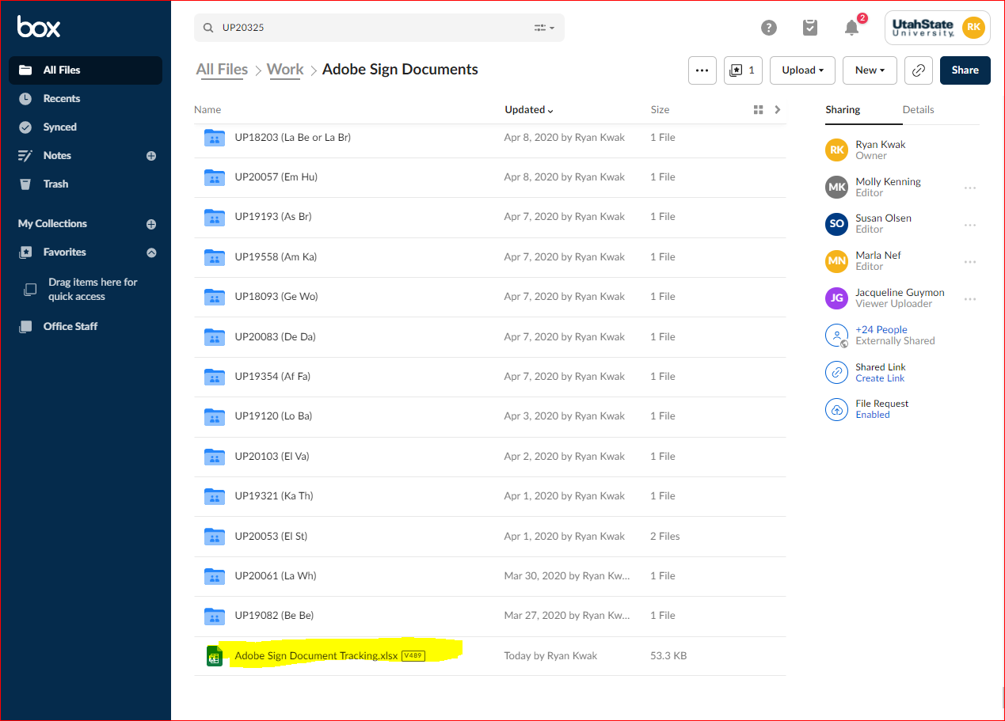

  - The Excel tracking sheet has a list of all the documents we have received in Adobe Sign. Each entry has the child’s initials, UP#, service coordinator, what document was received, and the date it was filed.
    - This tracking sheet can edited by selecting the down arrow next to the “Open” button at the top right of the screen and then clicking “Microsoft Excel Online” which will open the Excel sheet online where you can edit it.

