BDI Intake Evaluations
All intake BDI evaluations will be completed by BDI evaluators.
Process:
- BDI evaluators will establish their weekly schedules in webapps scheduling.
- Intake staff will schedule the initial BDI at the end of the intake conversation. They will schedule directly with the parent so the parent has the name & contact information, date and time of the BDI at the end of the call. The goal is to have the BDI completed within 2 weeks of the referral date. They will put the BDI date and time on the Intake paper and entered appointment into Webapps.
- The intake office staff will also give the parent your mobile number. The program will provide you with a $10-15/month phone allowance, to accommodate use of your phone.
- The intake office staff will send a packet with map, parking pass if needed, and COVID instructions.
- The SC and the other team members can see the initial BDI date and schedule accordingly.
- The evaluator is responsible for ensuring that a Prior Notice is sent to the parent at least 2 days prior to the scheduled date.
- The BDI evaluator is responsible for administration and scoring of the BDI. They will put the scored BDI in the child’s chart within 48 hours of administration.
- Cancellations/No Shows:
  - The family will be instructed (by intake staff) to contact the BDI evaluator directly to cancel the BDI. The BDI evaluator will inform the SC.
  - The BDI evaluator will notify the SC of no shows.
  - The evaluator is responsible for rescheduling with the family, putting the new appointment in Webapps, letting the SC know the reschedule date.
  - NOTE- A new Prior Notice will need to be completed for the change of dates.

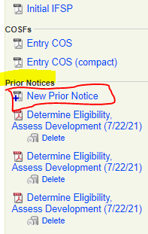
Sending Prior Notice through BTOTS:
Go to child’s BTOTS chart, select Summary tab
  - In the right hand margin, you will see Prior Notice (in blue)
  - Click New Prior Notice- in date put the date you are completing the form. Check To conduct an evaluation….
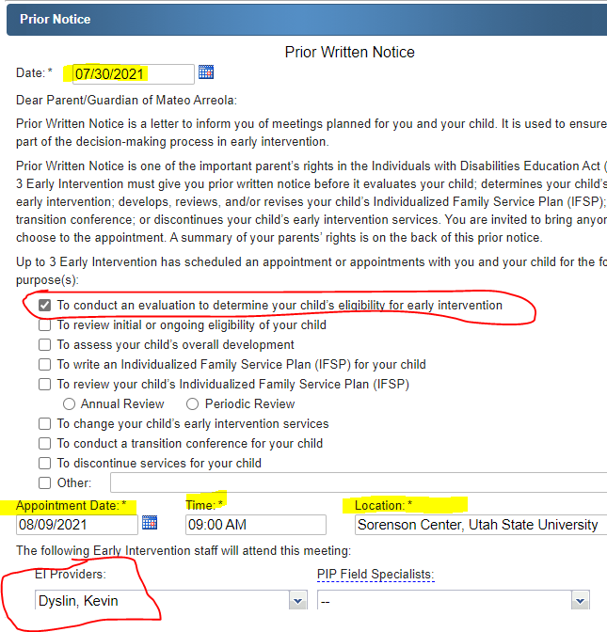
  - Add appointment date and time, location (Sorenson Center, Brigham Center, Tremonton Center, and select yourself under EI Providers.
  - When you select Save, the document will be saved in the parent portal and the parent will receive an email notifying them.

Getting Permission to Evaluate: Two ways BTOTS or Paper
First look in child’s BTOTS chart to see if a consent has been obtained by another Up to 3 provider.
Go to child’s chart, select eligibility tab: if there are dates in Consent & Booklet that are within 45 days of the current date, the consent has been completed.
If there are old dates or no dates consent hasn’t been completed

- Through BTOTS: Go to child chart, select Eligibility tab, if you see that there is a current form, you do not need to get another.

- If Consent Date is blank – you will need to get a consent
- Select Add,
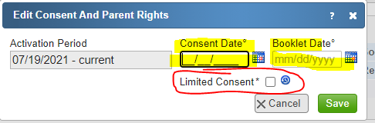
  - Review to Consent to Evaluate information with the parent. Ask if they consent, enter current date.
  - If the parent does not want testing in one or more areas, click the box by Limited Consent. You can unselect the areas the parent does not want assessment (example gross motor). You will not do and of the areas that the parent declines assessment.
  - Review the Baby Watch Parent Right Handout, enter date. Parent Rights document is in the Staff Resouces on the Up to 3 website page, under Forms.
Link to document: https://cpd.usu.edu/up-to-3/staff-resources/_staff-docs/forms/Parent%20Rights%20EN.pdf
  - Select save
  - Click Sign Consent
  - Follow directions to have parent sign – enter password, select drop down under signer, parent name should be available, have them using the mouse or mouse pad.
  - Select Sign & Finish
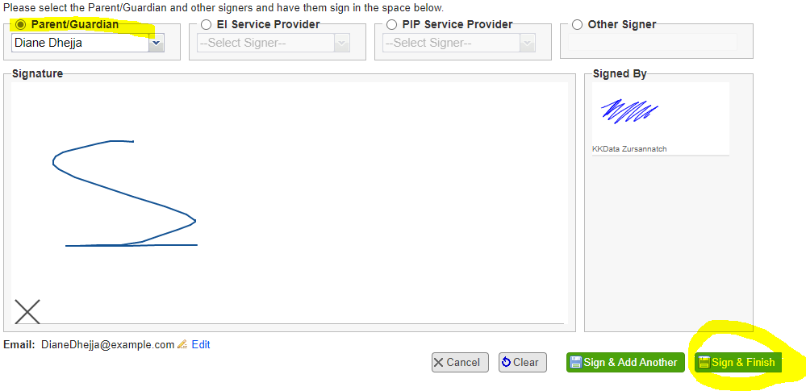
Use a paper Permission to Evaluate. These ae available in all of the offices. We have them in Spanish and English. You must also review the Parent Rights, there should be copies in each testing room in Spanish and English.
  - If the parent indicates that they do not want their child tested in all areas you will have them initial by the domain(s) they do not want testing. You would ONLY test the areas that they agree to have evaluation.
  - The form would be filed with the BDI protocol in the child’s chart either in Logan or Brigham City.
- Cancellations/No Shows:
  - The family will be instructed (by intake staff) to contact the BDI evaluator directly to cancel the BDI. The BDI evaluator will inform the SC.
  - The BDI evaluator will notify the SC of no shows.
  - The service coordinator (SC) is responsible for rescheduling with the family, putting the new appointment in Webapps, letting the BDI evaluator know the change to their schedule and sending Prior Notice.
Entering documentation information into BTOTS
- Evaluator will enter the required information into BTOTS including assessment date, linking associate the evaluation, Prior Notice Date, assessor name and BDI raw scores visit note in BTOTS.
- The BDI evaluator will enter a BTOTS electronic visit note to document the date and time of the evaluation visit or a no show visit.
  - You will only do one visit note for a BDI even if it is completed (interview one day and in-person manipulative another). Enter the visit note for the 1st visit and then edit with information on the 2nd visit.
  - You will select under Visit Status either Appointment ept if your 1st (or only visit) is at an Up to 3 center. The Service Setting would be Other, location either USU or Brigham or Tremonton center. OR
  - Under Visit Status select Virtual Home Visits if your 1st visit is over a zoom call. The Service Setting would be Home.
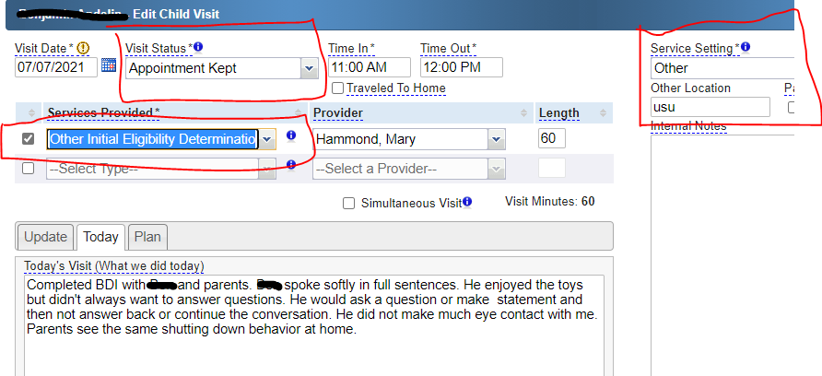
Documenting BDI visit when 1st or only appointment is at one of the Up to 3 centers
OR

Documenting BDI visit when 1st appointment is done as a Virtual Home Visit (zoom)
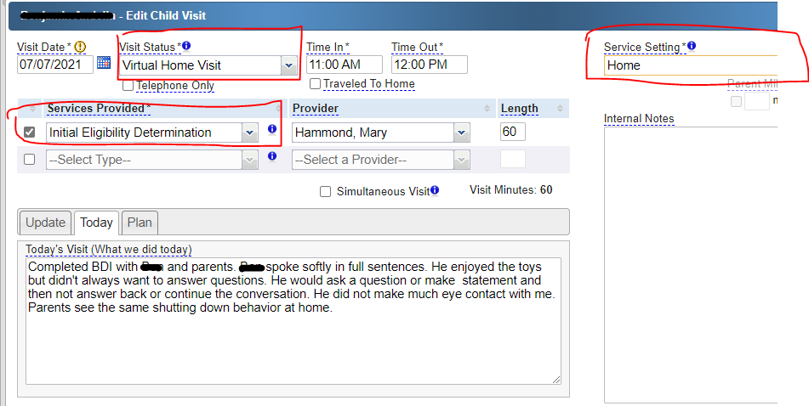

- Contact Log: The BDI evaluator will enter BTOTS contact log notes to document all communications with the family. Under Reason for Contact, select Initial IFSP Meeting. Always note the purpose of the contact and document the date of reschedule in the notes. If the parent declines to reschedule with you at that time under Family Declined to Schedule Yes.
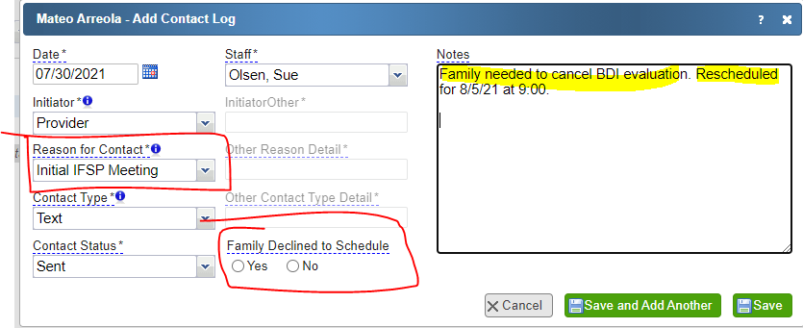

- When you do a BDI and you complete the visit at the Sorenson and do an interview on the same day you would do one visit note. Use the service setting for which every part you do first either at the Sorenson- list service setting as other or using virtual – see next comment.
- OR, when you do a visit note and your visit has been virtual you would select Virtual Home Visit under the visit status dropdown list.
BDI Kits: At this time we have enough BDI kits for each evaluator to be assigned a kit.
- You are responsible for maintaining the kit. If pieces are lost or broken talk with a program administrator about replacement pieces.
- Clean the kit have each use. The program has sanitizing wipes.
- Wipe down the tables and chairs of the testing room and leave the rooms ready for use.

