Onboarding for BDI evaluator training
Steps to Learn & Pass off BDI

- Attend a BDI in-person training.
- Accept Up to 3 Canvas invitation.

1st - Complete Summer’s training, read any assigned portions of BDI manual
2nd - Practice giving the BDI by yourself to learn organization and become familiar with materials
3rd - Practice giving BDI on an adult (coworker)
3rd - Practice giving on typical child
4th – Complete 2-3 BDI evaluations with Up to 3 new initial eligibility, annual eligibility, or exiting child
5th - Complete a permission to video form with parent and video a BDI administration.
- Find the form on Up to 3 webpage, staff resources. Link to permission to form, https://cpd.usu.edu/up-to-3/staff-resources/_staff-docs/forms/permission%20to%20share%20video%20and%20picture%20fillable.pdf
- Upload to canvas Video pass off assignment for Summer to review and provide feedback.

Scheduling Process:
- BDI evaluators will establish their weekly schedules in webapps scheduling. Miriam will give you a username and password. She can also train you on how to use webapps.
- Intake staff will schedule the initial BDI at the end of the intake conversation. They will schedule directly with the parent so the parent has the name & contact information, date and time of the BDI at the end of the call. The goal is to have the BDI completed within 2 weeks of the referral date. The office intake staff will put the BDI date and time on the Intake paper and entered appointment into Webapps.
- The office intake staff will also give the parent your mobile number. The program will provide you with a $10-15/month phone allowance, to accommodate use of your phone.
- The intake office staff will send a packet with map, parking pass if needed, and COVID instructions.
- The SC and the other team members will be able to see the initial BDI date and schedule accordingly.
- The BDI evaluator is responsible for administration and scoring of the BDI and entering BDI raw scores into BTOTS (see below). Evaluator will put the scored BDI in the child’s chart within 48 hours of administration.
- Cancellations/No Shows:
  - The family will be instructed (by intake staff) to contact the BDI evaluator directly to cancel the BDI. The BDI evaluator will inform the SC.
  - The BDI evaluator will notify the SC of no shows.
  - The evaluator is responsible for rescheduling with the family, putting the new appointment in Webapps, letting the SC know the reschedule date.
  - NOTE- A new Prior Notice will need to be completed for the change of dates.
Scheduling Annual BDI Evaluations
- The BDI evaluator will schedule the upcoming month’s annual and exit BDIs by the last Monday of each month no later than BEFORE the first Tues of each month. Let Miriam know if you have trouble signing in. Link for googledoc. https://docs.google.com/spreadsheets/d/1ON3RIcMOf6NR1RO8DdUXeG9785eWoikvC6n4H22fVC0/edit#gid=372363708
- Go to document, look at bottom tabs, go to the tab with the with the month you are scheduling.
  - Example: In Aug. you would be scheduling a Sept. appointment for an IFSP due in Oct.
  - Find the Oct 6-mo & annual tab, scroll down to where the annuals start, schedule BDI for the children listed with your assigned Service Coordinator. Put your name, date & time in column F.
- Look up parent contact information in BTOTS and call parents to determine a date & time.
- You will be responsible for contacting the parent to schedule, texting/calling to remind them, and sending a prior notice (see below).
Scheduling Exit BDIs
- The BDI evaluator will schedule the upcoming month’s annual and exit BDIs by the last Monday of each month no later than BEFORE the first Tues of each month. Let Miriam know if you have trouble signing in. Link for googledoc: https://docs.google.com/spreadsheets/d/1ON3RIcMOf6NR1RO8DdUXeG9785eWoikvC6n4H22fVC0/edit#gid=372363708
- Go to document, find the EXIT tab, look for children listed under your name.
- Look up parent contact information in BTOTS and call parents to determine a date & time.
- Put your date & time for a BDI in column G
- You will be responsible for contacting the parent to schedule, texting/calling to remind them, and sending a prior notice (see below).

Up to 3 Intake Process
- Office intake staff will complete intake process using Up to 3 intake form. Complete required ASQ, ASD questions - if needed complete ASQ S-E, and feeding questions.
- Molly Kenning will complete BDI for infants 11 months of age or younger, except Spanish speaking families.
- Children 12 months and older will be assigned to the BDI evaluator based on the Service Coordinator assigned. These are the current assignments as of Sep. 2021.

- Martha: all Spanish speaking families
- Flavia: Jordan
- Lisa: Becca and Heather
- Tessa: London, Jacque, & Lindsey
- Emma: Jamie
- The intake staff will identify and confirm a BDI evaluation day and time with the parent. They will give the parent the evaluator’s name and cell phone with instructions to contact the evaluator if they need to cancel and reschedule the BDI.
- Each BDI evaluator will block time in Well Sky a month in advance. Talk with Miriam if your schedule needs to change. The schedules are flexible but it is most helpful if your schedule stays the same each week. The intake staff will put the initial BDI into your well sky schedule. They will always schedule at least 30 min. between appointments. Most BDIs take 60-90 minutes once you are comfortable and familiar with the test administration.
- It is your responsibility to check you Well Sky schedule for appointments. If the family needs to reschedule you will be responsible for rescheduling.
- And contacting the child’s service coordinator so she knows if she needs to reschedule any of the other assessment or IFSP meeting
- Always notify Miriam 435-797-3727, miriam.williams@usu.edu when you need to cancel. Miriam can help with trying to get someone else to do the BDI at the scheduled time. If not, you will need to contact the family to cancel and reschedule.
NOTE: We have 45 calendar days to complete the full eligibility process and write an IFSP. A BDI must be done on each child before determining eligibility. Your role is crucial to the timeline.
- You must always call the family and introduce yourself and find out if the parents have any questions. They will have received an intake packet with an Informed Consent for Parent COVID pandemic and university activities (they should sign and bring with them), directions/map, a parking pass (if needed), and COVID information.
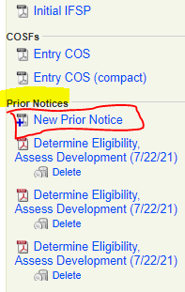
- There are parking passes, informed consent forms in the testing rooms if the parent forgets.
- Sending Prior Notice through BTOTS:
Go to child’s BTOTS chart, select Summary tab
  - In the right hand margin, you will see Prior Notice (in blue)
  - Click New Prior Notice- in date put the date you are completing the form. Check the box by To conduct an evaluation….
  - Add appointment date and time, location (Sorenson Center, Brigham Center, Tremonton Center, and select yourself under EI Providers.
  - When you select Save, the document will be saved in the parent portal and the parent will receive an email notifying them.
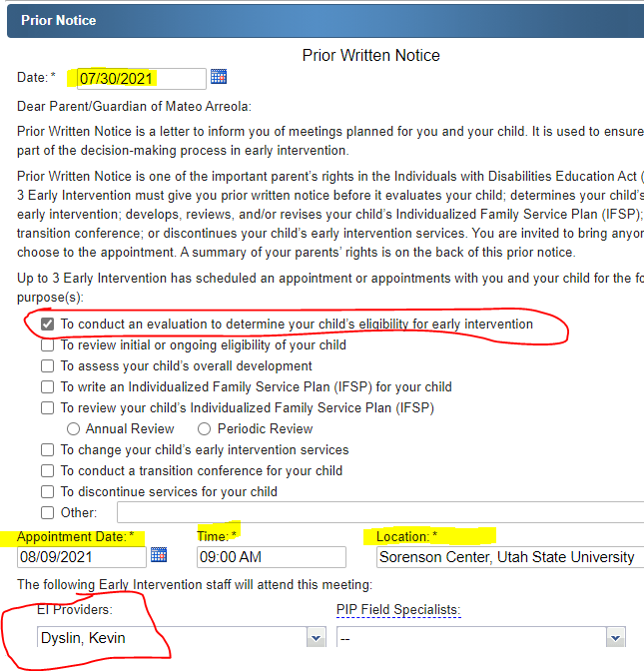
Day of Evaluation:
- Go to the testing room 30 min. before appointment to set up and wipe down table & chair surfaces with Clorox wipes.
- Wear a mask initially to meet the parent at the parking lot. For USU give them a parking pass if they have forgotten.
- Ask them the COVID questions. If they report to be healthy, you can all enter the buildings.
- Parents should be asked to wear a mask until they get into the testing room. If you and the parent are in agreement both you and the parent can remove your mask or keep them on.
Next Steps:
- If there is not a current consent to evaluate signed, you can get a paper form signed or do a BTOTS consent.
- To do a BTOTS consent – go to the child’s BTOTS chart, select Eligibility tab. Under Consent to Evaluate and Parents Rights Booklet, select Add, enter the current date.
- Provide the parent with a copy of the Baby Watch Parent’s Rights. Add the date to the booklet date field, Save.
- Select the Sign Consent icon. You will need to enter your BTOTS service provider password.
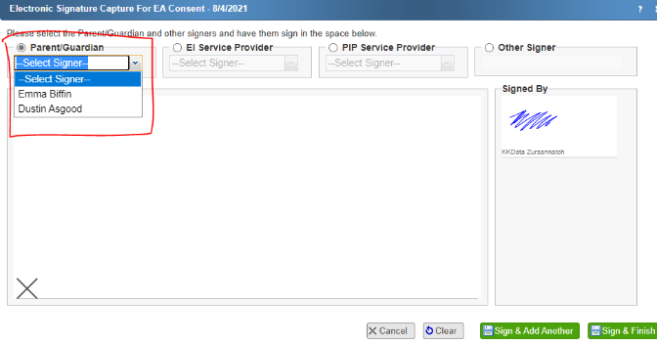
- Electronic Signature Capture for EA Consent will be available, select the radio button by Parent/Guardian, choose parents name from drop down list. Have parent sign by the X with the mouse. Select Save & Finish.

- You are ready to begin the BDI.

Following BDI evaluation
- You should ask the parent if they have any questions.
- You won’t be able to give them any scores or results. Let them know that their service coordinator will be explain the scores and eligibility questions.
- Note any comments they make e.g., “He wasn’t feeling well today.” In the TODAY section of the visit note (see the section below on Documenting BDI visit)

Scoring and Entering Raw Scores into BTOTS
- Score the BDI using the appropriate tables. If you have questions Summer can provide directions.
- Go to Visit Notes tab and enter a visit note. Note: BDI evaluation should be reported in a single visit note even when testing occurs on 2 days.
- The BDI evaluator will enter a BTOTS electronic visit note to document the date and time of the evaluation visit or a no show visit.
  - You will only do one visit note for a BDI even if it is completed (interview one day and in-person manipulative another). Enter the visit note for the 1st visit and then edit with information on the 2nd visit.
  - You will select under Visit Status either Appointment Kept if your 1st (or only visit) is at an Up to 3 center. The Service Setting would be Other, location either USU or Brigham or Tremonton center. OR
  - If your visit is over zoom call, Under Visit Status select Virtual Home Visits. The Service Setting would be Home.
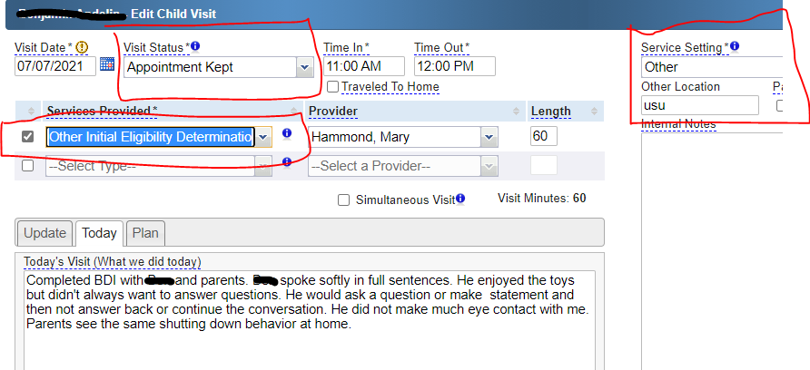
Documenting BDI visit when 1st or only appointment is at one of the Up to 3 centers

OR
Documenting BDI visit when 1st appointment is done as a Virtual Home Visit (zoom)
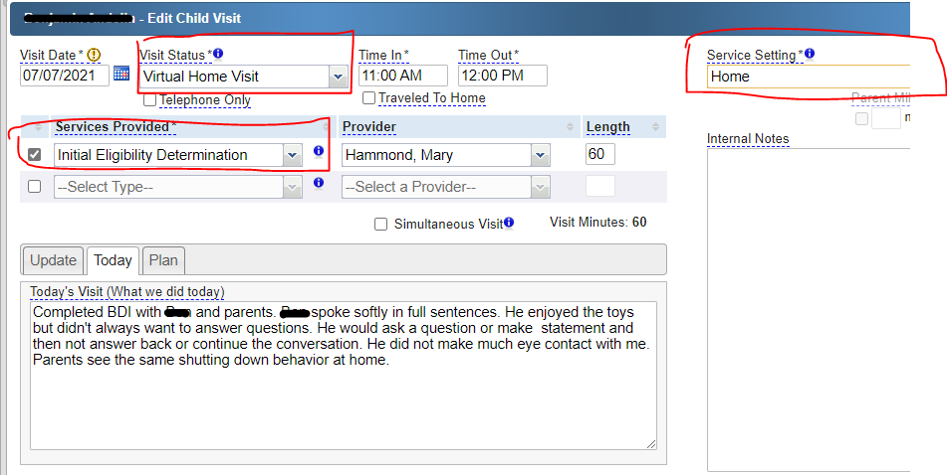

Provide the following documentation in the visit note tabs
Update tab: Any new information about the child the parent wants to share, e.g. “He’s had a cold”. If the parent states that there is nothing new – state that in the notes.
Today tab: Make statements about purpose of today’s visit and any observations about the child/ parent. See above screen shot. Also write one or two items the child can do from each area of the test (gross motor, fine motor, cognitive, receptive and expressive language, social/emotional, and adaptive).
Plan tab: You should share with the parent the next steps they should experience.
- If they haven’t, they will be contacted by their service coordinator about other appointments and next steps. The service coordinator will review these test results at the IFSP and eligibility meeting.
Internal Notes: On the right side of the form there is an internal notes box. Information put in this box is not visible to the parent on their copy of the electronic visit note.
- You can put statements like: “Mom was very emotional. She is very concerned.”
Entering BDI scores in BTOTs
- Go to the child’s BTOTS chart. Select eligibility tab. In the middle of the page in blue select Add BDI-2NU Evaluation.
- Enter the consent and booklet dates, if requested from the top of the page.
- Enter assessment date, using the dropdown list find your Associated Visit note. If you haven’t completed a visit note, BTOTS will create an alert, but allow you to continue. You must do the visit note and then go back and select the associated visit.
- Enter the date you sent the Prior Notice. You can go to the Portal tab and find the Prior Notice document that you completed and was emailed to the parent.
- Select yourself from the dropdown list.
- Enter raw scores.
- BTOTS will do the rest of the scoring.
- Select Save

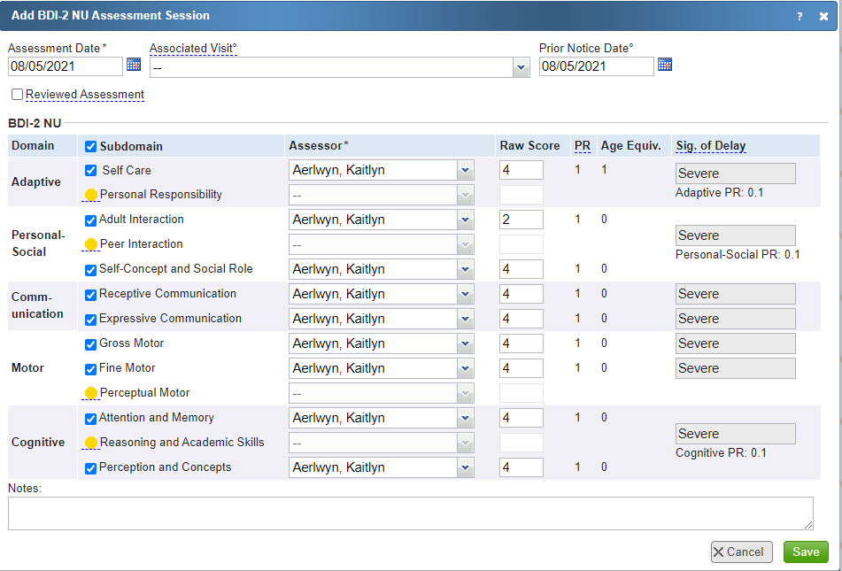
Documenting calls, texts, email contacts
- Contact Log: The BDI evaluator will enter BTOTS contact log notes to document all communications with the family. Under Reason for Contact, select Initial IFSP Meeting. Always note the purpose of the contact and document the date of reschedule in the notes. If the parent declines to reschedule with you at that time under Family Declined to Schedule Yes.
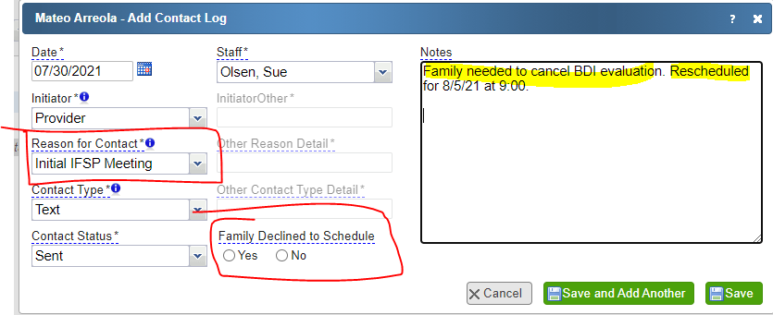

BDI Kits: At this time we have enough BDI kits for each evaluator to be assigned a kit.
- You are responsible for maintaining the kit. If pieces are lost or broken talk with a program administrator about replacement pieces.
- Clean the kit have each use. The program has sanitizing wipes.
- Wipe down the tables and chairs of the testing room and leave the rooms ready for use.

