September 17, 2019
Please begin today using the following guidelines when writing outcomes. You may want to make copies of current outcomes and talk with your team to revise outcomes at 6-months & annuals.
On Oct 15th in staff meeting, we’ll revisit this form and would like your tips and suggestions or possible revised improved outcomes.
Please sign the last page of this memo and Put in Sue’s yellow folder outside her door.
Preparation:
- Start with parents’/caregivers’ concerns and priorities about child’s learning and development and/or family’s needs. It’s critical to start with the parent’s/caregiver’s priorities about what they hope for the child and family and what’s most important or meaningful to them. Special focus should be placed on their desires related to participation in family and community activities. Using focused open-ended questions can help parents and other care providers reflect on how they want the child to participate in activities and routines that are meaningful to them and what factors impact their child’s successful participation. It is these family priorities, not the practitioner’s or teacher’s priorities, that should serve as the basis for a high quality, participation-based outcomes and goals.

  - Information is gathered from SC Concerns, Priorities & Resources (CPR) interview and therapist’s discussions during assessments.
  - Information is summarized in the Present Level of Development (PLD). Therapists document information gathered in their visit notes.
- Consider what’s working and what’s challenging in everyday routines and activities. Make note of those situations that are motivating and interesting to the child and family and those that impact participation in family and community life. Asking parents what the child enjoys doing and what they enjoy doing together helps to clarify the context where the child is learning and participating. Similarly, asking parents which parts of their day are not going well provides an understanding of what the parents would like to see different in the future.
- Consider how the child’s development (from your assessment and parent report), needs, and disability influence the child’s learning and participation in everyday routines and activities. The third piece of information needed is what has been learned from evaluation and assessment. The professional must incorporate what has been learned during the evaluation and functional assessment process about the child’s developmental skills, needs and disability and their impact on the child’s learning and participation. Individual therapists’ knowledge of development will transform this information into outcomes.
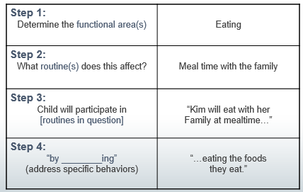
Identify components to help develop outcomes.
- Determine functional area
- What routine/activity does it affect?
- Does the child participate? Does the family participate? (write family outcomes as needed)
- How does the child participate?

Third Word Rule:
Develop outcome to address priority by identifying what the child/family will do:
Child or family (participant) will ______ (third word rule means third word is action) include description that helps it be measurable.
Review the outcome you’ve written. Is it:
Necessary and functional in child and family’s life and/or reflective of real-life context and settings?
Discipline-free (not discipline-specific)?
Jargon-free, clear and simple?
Written in positive, not negative?
Writing with action words rather than passive?
Measurable?

Outcomes will be monitored through program quality assurance review for these 6 categories
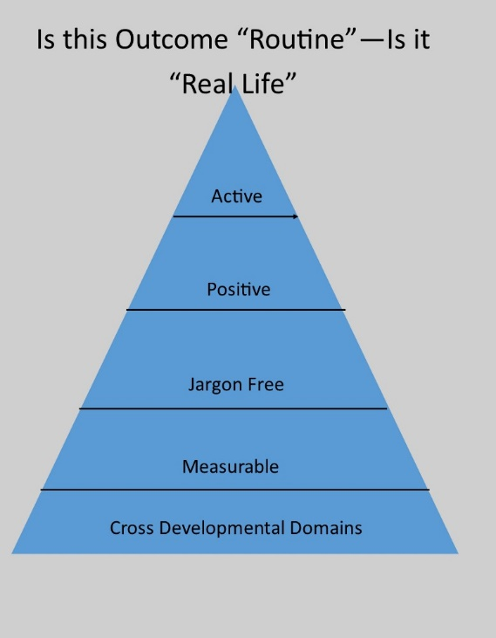

I have reviewed the Up to 3 memo - “Up to 3 Process for writing Functional Outcome”. I understand that program monitoring will review outcomes based on the 6 categories in this program policy.

Name: ___________________________________________

Date: ______________________________________________

Detach this last page and put in Sue’s yellow folder

