Process to exit a child from Up to 3
IDEA regulations Transition plan:
Transition plan. The State lead agency must ensure that for all toddlers with disabilities—
(1)
(i) It reviews the program options for the toddler with a disability for the period from the toddler’s third birthday through the remainder of the school year; and
(ii) Each family of a toddler with a disability who is served under this part is included in the development of the transition plan required under this section and §303.344(h);
(2) It establishes a transition plan in the IFSP not fewer than 90 days—and, at the discretion of all parties, not more than 9 months—before the toddler’s third birthday; and
(3) The transition plan in the IFSP includes, consistent with §303.344(h), as appropriate—
(i) Steps for the toddler with a disability and his or her family to exit from the part C program; and
(ii) Any transition services that the IFSP Team identifies as needed by that toddler and his or her family.

Related DEC Recommended Practices:
Family Practices F2: Practitioners provide the family with up-to-date, comprehensive and unbiased information in a way that the family can understand and use to make informed choices and decisions.
Example: In preparation for transition, a service coordinator supports the family’s interests in exploring programming options by helping the family gather and evaluate information about the effectiveness of each option
Transitions: TR1: Practitioners in sending and receiving programs exchange information before, during, and after transition about practices most likely to support the child’s successful adjustment and positive outcomes.
Example: A director of the preschool electronically submits the academic records for each child who is moving to kindergarten and for whom the parent has given permission, to ensure that each child’s prior information is included in the district’s data base.

Transition: TR2: Practitioners use a variety of planned and timely strategies with the child and family before, during, and after the transition to support successful adjustment and positive outcomes for both the child and family
Example: A service coordinator provides families with lists of preschools and visiting schedules. She offers to accompany families on their visits to the preschools
Description:
Several situations may occur when a child will no longer be enrolled in early intervention. Procedural Safeguards and Parent’s rights, as well as Prior Written notice are required depending on the exit reason.

Training:
Onboarding introduction training for staff:
- Read/Watch these materials:
- 1) the entire Transition and Exit information – this document 2) Transition and Exit process practice & checklist, 3) Service Coordinator and Transition service array document, 4) BWEI BTOTS documentation for Transition and exit on UEN canvas, 5) BWEI Transition guide, 6) BTOTS training videos for Transition
- Read BTOTS trainings on transition and Exit in UP to 3 handbook at these links:
  - Referral notification
  - Transition Conference decline
  - Powerpoint on transitioning children to school district: found on upto3.org resources btots training, transition
- Practice Process:
  - 2020 QAP special attention being given to specific steps of 1) individualize information on Referral Notification Discussion. 2) include outcomes on Plan: Special Education Tab 3) Discuss Transition at every IFSP and document in the notes

Training activities for training facilitator or mentor:.
1) Observe these visits or watch 1 video of transition discussion and 1 video of transition conference and review your notes and descriptions with mentor.

The Service Coordinator is responsible for Transition and Exit. However, it is important to understand the context of the family and the supports they have or don’t have, especially from the UP to 3 team. As you view the videos below,
Select and complete two or more of the practice steps while watching the videos.
1. Practice taking notes.
2. Jot down questions you’ve heard, those you were surprised you didn’t hear, and any questions you had or that you would have asked.
3. Describe what you noticed about non-verbal communication from both the interviewer and the family member/caregiver.
4. Reflection opportunities- What are you wondering about after watching the video? What questions do you have about the process? What additional information do you need? How will you incorporate what you’ve learned into your own practice?

- Always seek feedback, mentoring and/or coaching from a peer service coordinator or office clerk.
Transition Guide checklist

Steps to Exit for each exit reason

No Longer Eligible for Part C Prior to reaching age 3
- Only applicable at annual Eligibility Determination
- Send Prior Written Notice for evaluation, to review initial or ongoing eligibility of your child, and annual review.
- After evaluation when it appears child may not be eligible, but before determining eligibility, send Prior Written Notice to discontinue services for your child.
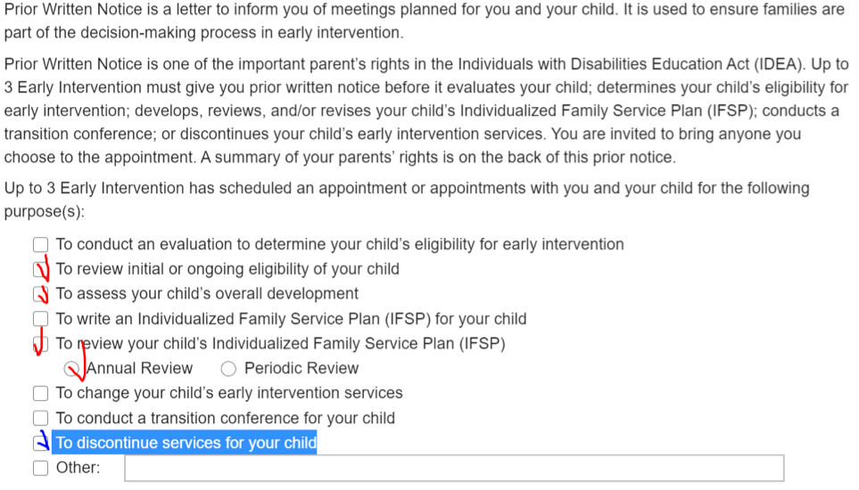
- Complete evaluations in all areas, including Health, Hearing, and Vision. A child cannot be determined not eligible at annual when they have a mild delay in any area.
- Complete the Exit Child Wizard in btots. Document in the exit notes section a brief summary of why child is no longer eligible
  - Mark date No Longer Eligible as same as eligibility determined date. Complete Summary of Ineligibility and Recommended Next Steps. BTOTS will send Written Notice of Ineligibility when this exit reason is completed in btots.
  - It will require updated exit assessment, rating outcomes, transition updates.
- Help parents complete Help Me Grow Utah (HMGU) online application or gather information from parent to complete this application following the meeting. Complete HMGU within 2 days of child exit.
- Complete visit note.

Part B Eligible
- Transition:
  - Referral Notification Transition Discussion: SC discusses transition options with parents at least 26 months before 3rd birthday. If parent opts out of transition to school district, mark that box and record notes from the transition discussion in each box on Referral Notification Discussion Page in btots. Be sure to document specific information individual parent needed to know and not just restate what the heading to the box says. Include information from the brochure rather than just writing “Transition brochure given”. Specific information shared or questions the parents have are great to include.
  - Transition Plan Discussion: SC discusses and documents transition to school district including:
    - Skills child needs to prepare for preschool (Btots “Plan:Special education b)
      - Complete Preschool Preparedness checklist.
      - Discuss child needs regarding participation in school district or other setting.
      - Does the current IFSP contain outcomes to address these skills? If yes, note the outcomes in btots Plan: Special Education c. If not, develop outcomes and add them to the IFSP. Note them on Btots Plan: Special Education c.
    - Outcomes to address these skills
      - Develop outcomes to address the skills and note them on btots Plan: special education c.
    - Release and exchange of information with the school district
    - Possible date/times for Transition Conference with the school district
      - Have parents sign the Release/Exchange EI record form
    - Other community options.
      - This becomes available when Referral Opt out is chosen or parent declines Transition Conference.
      - Give the family the Community Options Brochure
      - Complete Transition Community Planning tab.
  - Transition Conference: SC sets up a meeting with the local school district representative and the parents to discuss parent’s concerns, how eligibility for Part B is determined, and plan when the evaluations and IEP will be held.
    - SC schedules this to happen AT LEAST during the month prior to turning 33 months. It can be held earlier (as much as 9 months earlier)
    - SC sends parents Prior Written Notice regarding the date of the Transition Conference
    - SC discusses with parents who else may need to attend the Transition Conference and invites them (for example PIP, Sound Beginnings, Early Head Start, other community providers
    - SC attends Transition Conference, facilitates discussion to help identify which testing is needed and when Part B evaluation and IEP will be held. SC and documents notes on Transition Conference Page and has Part B rep, Parents and all attending to sign this form.
    - IF Transition Conference is late, SC completes delay reason in btots and includes notes cause and occurrences leading to late conference. These notes should also be in the Contact logs or visit notes.
    - SC completes visit note for Transition conference and links it as an associated visit to the transition conference.
- Complete the Exit Child Wizard in btots. Document in the exit notes section when child was determined Part B eligible (date of IEP) and how that information was obtained (attended IEP, talked with mom, talked with school district).
  - For all exit reasons EXCEPT part B eligible, deceased, moved out of state, or moved to another EI program in the state, SC will also include in exit notes that Help Me Grow Utah (HMGU) online application was completed with the parent or information gathered from parent to complete this application following exit. Complete HMGU within 2 days of child exit BDI will need to be updated for Exit COS. (Documenting HMGU discussion and other community options in exit notes meets the requirement as in exit reason “Not eligible for Part B, exit to other programs”)
  - Unless exceptions noted below, BTOTS will require updated exit BDI for Child Progress, outcomes rated, and transition updates.
  - For exit reason: Not eligible for part B, exit with no referrals, SC will still document HMGU completion.
  - For exit reason: Part B eligibility undetermined, transition conference declined:
    - Opt Out Discussion should be marked that parents opted out if they declined before 27 months.
    - Exit reason is Part B Eligibility Undetermined, Transition Conference Declined when parents declined Transition to part B after child turned 27 months. In this case, information was sent to the school district and it is not possible to mark that the parents opted out. Instead, SC will mark declined on Transition Conference page. Complete the date declined and include in transition conference notes, and exit notes the date and reason parents declined.
    - IF parents Opt Out before 27 months, SC will mark that on the Referral Notification Page and exit reason will be Part B Eligibility Undetermined, Opted Out of Referral Notification.
    - IF exit reason is Part B Eligibility Undetermined, SC will include in the exit notes what happened. Include necessary documentation such as attempts to contact unsuccessful, contact informing SC parents are moving, etc.
    - If exit reason is Part B Eligibility Undetermined, Referred Results Unavailable, SC will include in exit notes brief explanation of the situation. (“School district unable to test due to COVID/natural disaster” or “district lost test results”, etc.). This is also the exit reason used when Part B eligibility is available but it was determined AFTER the child’s third birthday.
    - IF exit reason is Deceased before age 3, child will not need Child Progress updated or transition past what had occurred.
    - IF exit reason is Moved out of State Before Age 3, SC will update BDI and complete Child progress, but only need to complete necessary transition steps up to age at exit.
    - If exit reason is Withdrawal by Parent, SC will include in exit note date this was communicated to SC and what additional query happened along with parent answer. SC will help parents apply online for HMGU and offer other applicable community resources. If further enquiry reveals parent fee was the concern, program director should be consulted as the fee may be waived.
    - If exit reason is Attempts to Contact Unsuccessful, documentation should be found in contact log and missed visits. SC will also briefly describe in exit notes attempts to contact. If not BDI was completed in the past 6 months, no child progress can be updated. No HMGU will be completed either.
    - If exit reason is Moved to Another EI Program in the State, SC will mark which EI program they moved to and include updated address or phone number if available. Update Child Progress if it is known they are moving in enough time to complete BDI.

