WHY? Routines based on parent input are the focus of functional outcomes.
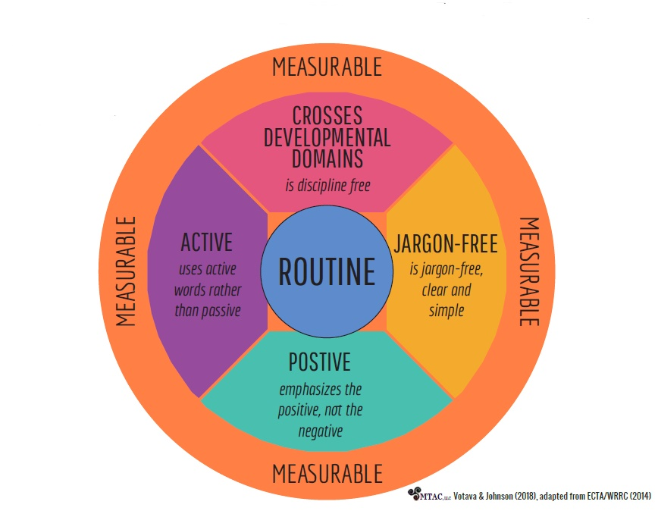
WHAT? The 5 components help focus on the routine.
HOW? During assessment, every provider asks about family concerns & asks probing follow up about why that concern is important to the family. On paper IFSP form, every provider writes family concerns in PLD section. To make it easier to capture what to put in concerns section, lets also document on visit notes in the “Plan” section on electronic notes and in the Family Information section on paper notes. Then team members always know which part of the visit note to find concerns/routine info in. Ryan will put it in btots visit notes when entering data.
Another tip to help writing functional outcomes in the attached template so its easier to know where to plug things in.
Measurable
- This is where parents can see it is accomplished in the routine (numbers not needed)
- “We will know when he reaches this by …”.(this is where the numbers can be so therapists can see its met)

Crosses domains/Discipline free (naturally comes as we address whole child in routines)
- Promoting skill development across multiple domains
- Any member of the child’s IFSP team can address

Jargon free
- Written for family and general public understanding
- NOT include professional jargon
- Instead of “range of motion”, describes how child will move (like reaching up or down -or-
- Ability to speak words clearly to make self understood rather than “articulation”

Positive
- States what the child or family will do to participate
- Focus of whole outcomes is positive
- NOT what child and family will not do or stop doing
Example: Johnny will chew and swallow food when eating with his family” rather than “Johnny will NOT spit out food when eating with his family.”

Active NOT passive
- Words encourage child &/or family’s active participation or engagement.
- Includes words like “eat, play, talk, walk”
- Indicate what the child or family will do
- Passive words reflect state of being (tolerate, receive) or change or lack of change in performance (increase, decrease, improve, maintain.)

