The link to the school district map that we use is:
http://transdata.ccsdut.org/smap.html
The easiest way to use the map is to select all of the Logan school district boundaries on the menu bar titled "Boundaries and Stops". I have included a screenshot of the boxes that should be selected (circled in red). Once these are selected, the Logan school district boundaries will appear on the map as shown in the image. After the Logan boundaries are selected, just enter the address into the Address lookup menu (circled in blue) and it will drop a pin on the map. If you follow the link to the map, and the "Address Lookup
" and/or "Boundaries and Stops" bars are missing, just select the respective buttons for these menus that are located in the top right corner of the website.
Examples:
Cache
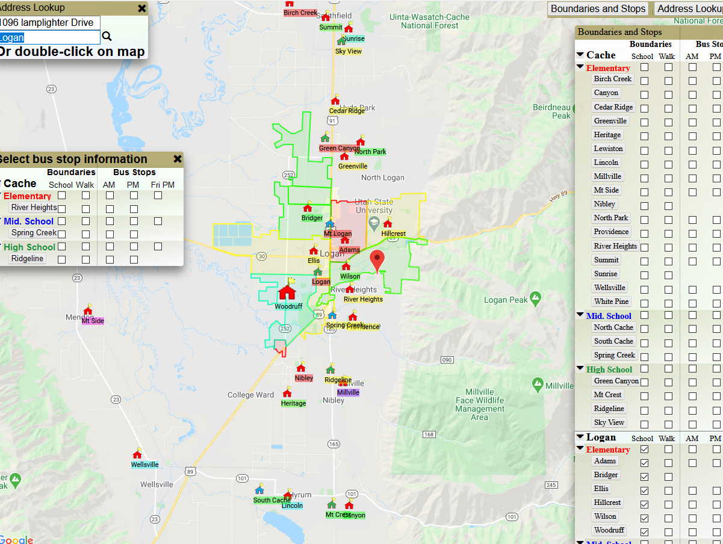

Logan
