Up to 3 Billing and Payment Registration Procedure

BTOTS Family Fee Billing Reports

Related DEC Recommended Practices:
- Family-centered practices: Practices that treat families with dignity and respect; are individualized, flexible, and responsive to each family’s unique circumstances; provide family members complete and unbiased information to make informed decisions; and involve family members in acting on choices to strengthen child, parent, and family functioning.
  - F1. Practitioners build trusting and respectful partnerships with the family through interactions that are sensitive and responsive to cultural, linguistic, and socio-economic diversity.
  - F2. Practitioners provide the family with up-to-date, comprehensive, and unbiased information in a way that the family can understand and use to make informed choices and decisions.
  - F3. Practitioners are responsive to the family’s concerns, priorities, and changing life circumstances.
  - F9. Practitioners help families know and understand their rights.

In alignment with the Baby Watch System of Payment and Fees Policy 1.C.1 the Up to 3 Early Intervention program is implementing the following procedures. See Baby Watch System of Payment and Fees Policy 1.C.1 Payment Fee System policy.pdf (utah.gov)

The billing and payment system allows families who are receiving Early Intervention services to do the following: Complete their online family fee assessment, make online payments, adjust billing preferences, and submit a billing dispute.

About Family Fees
- Family fees are a specified dollar amount that a family is expected to pay each month for Early Intervention services. The family fee is based on modified income, family size and ability to pay.
- Family fees are determined based on a sliding fee schedule, with information provided by the family including modified annual income and family size, in conjunction with the federal poverty level. Family fees can range from $0 per month up to $200 per month.
- BWEIP Family fee process is completed electronically on the Utah ID website. This is to allow financial information to be collected without EI staff gathering it. Families will be able to pay online or pay by check.
- If a family does not provide financial information to Baby Watch Early Intervention (online or submitted via paper to the Baby Watch Early Intervention billing office), by the 20th of the month after services are rendered, the family will be assessed a $200 fee for each month in which the information is not provided.

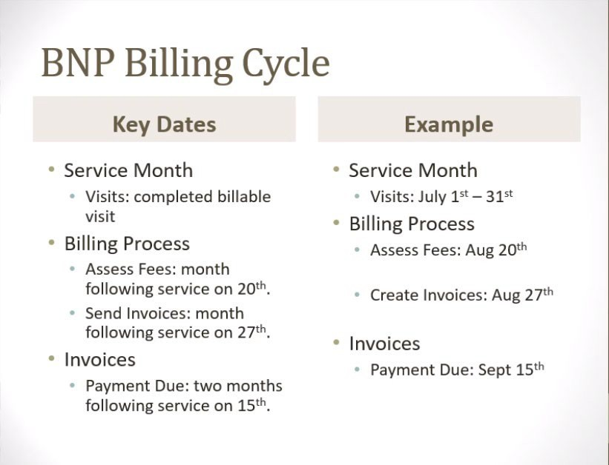

Informing families of the Family Fee registration process:

- Service Coordinators are responsible for giving families the BNP instructions print out from BTOTS that includes the Child’s ID and Family Fee PIN.
- Service coordinators should give the family the BWEIP Procedural Safeguards and No-Cost Protections Document and may also consider providing the Billing and Payment System Family Help Document. ( See Family Fee Resources below)
- At what point in the IFSP process can/should families complete the billing registration for initial and annual IFSPs?
  - For Initial IFSP
- At the FDA visit after eligibility has been determined.
- As per Baby Watch, “The parent can enroll the child in the BNP system even before their child is under IFSP. In this scenario, the family will be created and the child assigned, but they won’t have any fees assessed. Once the child is receiving services, the normal process will assess the fees.”
  - For Annual IFSP (or whenever their information expires)
- Family fee information is valid for one year from the last time it was verified/updated. This may or may not fall on the child’s annual IFSP review deadline depending on the last time it was entered/verified/updated.
- For annual renewal, the family must login and either update their financial information or indicate that it has not changed.
- ** Note – If the family has already received a $200 fee, they must also click on the “Submit Billing Dispute” link and enter a note stating that they have updated their financial information. (See the Billing and Payment System Family Help Document – Fig. 15 & 16).
- Paper fee form (English or Spanish as appropriate):
- When to use:
- When English is not the parent’s primary language
- Families that are struggling with technology/not comfortable with online
- Instructions for using the paper form:
- Send a copy of the paper form (faxing is preferred if email is not secure) and supporting financial information to the BW billing specialist (Fax # - 801-323-1565) (Temporary email – Jenny Allred at doh_eibilling@utah.gov).
- Service Coordinators should contact non-English speaking families, and work with interpreters as needed, to complete a paper form, fax it to the BW billing specialist, confirm that it was received and registered, and let Janeal know that a paper form was submitted.
- As of 11/10/2021, there is a support ticket for enhancing the “Families With No Family Fee Determination” report to indicate those families in which fee determination was recorded by the BWEIP billing staff (e.g., the family mailed the information in). A family that manually submitted their information and has not registered is still currently is showing as “Family Not Registered”. Baby Watch hopes to have this improvement out shortly.
- **Note – When there is an exempt fee – no financial information is required. However, the family still needs to “Opt-In”. (See the Billing and Payment System Family Help Document – Fig. 9).
- When there is a fee, provide the parent with billing specialist # 385-262-5909, contact BW billing. Billing specialist will answer any questions the parent has.

*Notes:
- Janeal will help service coordinators solve family fee issues when necessary.
- If families decide to withdraw from service at any point, service coordinators should identify if the withdrawal it is related to a fee or to the billing and payment system. The Fee form process had previously been based on relationship and trust between a family and the Service Coordinator. If the online system is mentioned, please inform a Program Coordinator and/or Janeal.

Janeal will run Family Fee BTOTS reports around the 21st of every month:
Families with no fee determination report:

- 1. For the first two months that a family appears on the report,
- Janeal will:
- Download and color-code the report to the Family Fee Reports document in Box.
- Family Fee Reports
- Below is the description of the color codes and actions required:
a. “The blue highlighted families are those whose fee information will be expiring soon or has expired. Except for those with a “Pending” status, I will be sending emails to these families on the 30th, informing them of their fee status. I will instruct families that are still showing up as “Fee Information Expired” that they will need to do the following:
    - Login to their family dashboard, go to the “Family Fee” tab.
    - If the family is on public insurance (e.g., Medicaid), click the “Edit Program Enrollment”, make changes if necessary, and then click “Save”.
    - If the family specified income information, click the “Edit Income Information”, make changes if necessary, and then click “Save”.
The yellow highlighted families are those who have appeared on the report as not being registered for ≤2 months, who have been deactivated <60 days but still need to register to avoid the $200 bill, or whose registration is incomplete. Please review the list and identify families to whom you prefer that I don’t send an email and make a note in the “Notes” column. I will be sending reminder emails to the remaining families on the 30th of the month. You may also follow up with families to determine whether barriers exist that are hindering the registration process. The red highlighted families have appeared on the report for 3 or more months and/or have no email address in BTOTS. These families require your intervention to assist them in registering. The green highlighted families are those who are non-English speaking families (some of which have also appeared on the report for 3 or more months) and may require that a paper form be submitted. “ The grey heighted families are those that have been deactivated >60 days, submitted a paper form, have extenuating circumstances, or should be removed from the report for various reasons. I have contacted BW financial to waive any remaining fees for these families. No action is required on your part.
- Email the service coordinators to inform them that the report has been uploaded.
- Upon receiving this email, Service Coordinators should review the list and take suggested actions based on the color code.
- Contact non-English speaking families, and work with interpreters as needed, to complete a paper form, fax it to the BW billing specialist, confirm that it was received and registered, and let Janeal know that a paper form was submitted.
- Be sure to note any actions taken in the “Notes” column of the spreadsheet.
- On the 30th of the month, Janeal will email the Billing and Payment Letter to families on the list based on the instructions for each color code.
- 2. In the 3rd month that families appear on the report:
- Service Coordinators should contact families to determine if there is a problem and encourage them to register.
- 3. After 3 months:
- Service coordinators will work with the direct service provider and the family by scheduling a visit to identify the barriers to completing the billing registration.
- If needed, Service Coordinators should help the family complete the registration (see resources below)
- As a last resort, have the family complete a paper form, fax it to the BW billing specialist, confirm that it was received, and let Janeal know that a paper form was submitted.

Late Payment Report/Exited Children with a Payment 30 Days or More Late Report:
      - Janeal will:
- Review the reports for accounts that need to be waived due to deactivation.
    - If the child has recently exited (45-60 days) Janeal will send the Exited with a Fee Letter to families asking if the parent can pay any of the fees owing and to disregard the email if they have recently made a payment.
    - Fees still owing by families who have exited/deactivated >60 days will be waived.

**Additional Notes
- In the “Family Fee Information” section of the Billing and Payment registration, there is a “Financial Information Valid Until” status that will identify when their information expires and will be reflected when the family correctly completes the steps to update their “Fee Information Expired” status (see 1.A.i. of this section for blue highlighted families).
- At both the initial IFSP and upon expiration of financial information, families should be reminded that if they do not complete the registration and fee information online, they will be charged the $200 fee for services received each month.
- Once the family registers the $200/month fee will be adjusted according to their determined fee.
- If there is an inability to pay because of a change to family income, the family must login and update their financial information. They must also click on the “Submit Billing Dispute” link and enter a note stating that they have updated their financial information. (See the Billing and Payment System Family Help Document – Fig. 15 & 16).
- If there are other extenuating circumstances (family emergency, had to buy new car, etc.) that are preventing a family making a payment have the family contact BW billing specialist billing specialist # 385-262-5909. The BWEIP billing specialist may email the program administrator about waiving fees owing.
- Service coordinators should also inform the BWEIP billing specialist of families that have 2 or more children enrolled in the program.

At Exit:
The Service Coordinator should remind families at exit to please pay any fees owing. Go to BTOTS, Family Fee Billing Reports > Late Payment Report.

Family Fee Resources:
- Family Billing and Payment System Video
- Billing and Payment System Family Help Document
- Family Fee Instructions Fillable Form
- Fillable Billing and Payment Checklist
- IDEA Fee Regulations
- BWEIP Payment Fee System Policy
- BWEIP Procedural Safeguards and No-cost Protections
- BNP Frequently Asked Provider Questions

