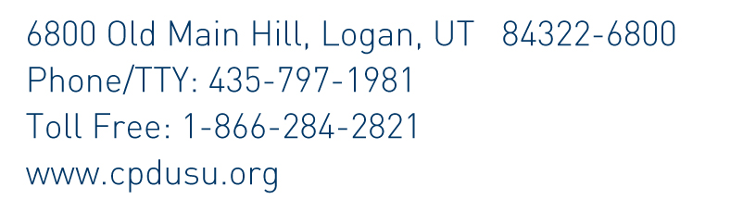

MEMO

To: Up to 3 staff

From: Marla & Sue

Date: April 13, 2019

Subject: Overtime

Please review USU policy 378: Overtime

Up to 3 procedures related to overtime

Overtime should be avoided through proper scheduling. Up to 3 nonexempt employees who work more than 40 hours per week, would earn overtime. Employees who recognize they will be working over 40 hours, should talk with Marla or Sue before working more than 40 hours. Working more than 40 hours in a week needs to be approved before it is worked. Aggie Time will document these hours as comp time. Comp time should be used within the pay period when it was earned.

If a non-exempt employee was planning to take vacation in the same time period as unscheduled hours would be worked, the comp time earned during this time period should be submitted instead of annual leave.

The following is from USU policy:

“Classified Employees

“The use of overtime is generally discouraged and should be avoided through proper scheduling of department workloads. With the exception of certain emergency situations, all overtime should be approved in advance by the department head/supervisor.

..” The overtime pay rate for non-exempt employees who work more than 40 hours in a week is one and one-half times the regular rate.

“In lieu of overtime pay, non-exempt employees may receive compensatory time off at a rate of one and one-half times the number of hours worked in excess of 40.

“Compensatory time off should be used within the same pay period that it is accumulated; however due to extenuating circumstances, supervisors may request that it be saved for use at a later date.

“In most cases, the maximum number of compensatory hours that can be saved before payment or time off must be given is 120 hours.

“2.3 Recording Hours Worked
Hours worked by all hourly/non-benefited employees and non-exempt employees in variable-hour positions must be recorded by the employee, approved by the department head/supervisor, and reported monthly using the University’s electronic payment system. The FLSA requires that complete and accurate time records be kept for all non-exempt employees, and that these records be kept for three years. USU requires a time keeping method that allows employees and supervisors to sign each monthly time sheet/card. All time records must be stored at the department/unit level.

2.4 Overtime Payment
Payment should be made within the pay period in which the overtime occurred. Salary payments for overtime are made using the Banner form PHATIME.

2.5 Holidays
The University observes specific holidays each year. For work scheduled on a holiday, employees will report as directed. Benefited staff are eligible for paid holidays. If a nonexempt employee works 33-40 hours in a week that includes a holiday, that time is paid as straight time. However, if that employee works more than 40 hours in a week that includes a holiday, those hours are paid at one and one-half times the regular pay.

378.3 RESPONSIBILITY

3.1 Department Heads and Supervisors
Responsible for approving overtime in advance and making sure new employees understand whether their positions are non-exempt (eligible for overtime pay) or exempt (not eligible for overtime pay).
Responsible for communicating the necessity of having to work overtime when requested as a condition of employment. Supervisors must approve the number of hours worked by an employee within the pay period and specify if a payment is for overtime.

3.2 Employees
Responsible for accurately recording work hours, cooperating with overtime work needs, and balancing University and personal needs when establishing flexible work schedules.

Also see policy 382: Standard Work Hours and Attendance https://www.usu.edu/policies/382/
Pay special attention to:
Classified Employees

Agreeing to work overtime when requested by a supervisor is a condition of employment. Refusal to work a reasonable amount of overtime, especially under emergency conditions, may result in disciplinary action.

The maximum number of compensatory hours that can be saved before payment or time off must be given is 120 hours for most employees and 240 hours for police officers and employees engaged in emergency work.

Benefit-eligible classified employees who must work on recognized University holidays must either schedule another day off within thirty days or be paid their regular compensation in addition to holiday pay.

