Institute for Disability Research, Policy & Practice

If COVID-19 Symptoms, What To Do & When to Return To Up to 3

SYMPTOMS OF COVID-19
The Centers for Disease Control and Prevention keeps an updated list of symptoms associated with COVID-19. Symptoms may be mild or severe and could include:

- Fever or chills
- Cough
- Shortness of breath or difficulty breathing
- Fatigue
- Muscle or body aches
- Headache
- New loss of taste or smell
- Sore throat
- Congestion or runny nose
- Nausea or vomiting
- Diarrhea

If your child or anyone in your household exhibits any of these symptoms, please let your Up to 3 provider know ASAP.
Please note: If your child or anyone in your household has pre-existing conditions that cause any of the COVID-19 symptoms, please discuss this immediately with your provider/service coordinator.

*According to the Utah Department of Health, anyone experiencing one of six symptoms should seek testing: fever, cough, shortness of breath, muscle aches and pains, decreased sense of smell, or a sore throat. If you are sick, you must isolate yourself at home to avoid spreading the illness to others.

IF ANYONE IN YOUR HOUSEHOLD HAS ANY COVID-19 SYMPTOMS, PLEASE NOTE THE FOLLOWING:
The following still apply regardless of testing positive in the last 90 days or completing the vaccine series (with the exception of exposure).

IF POSITIVE TEST: If your child or anyone in your household (see exposure rules below) tests positive for COVID-19, your child must self-isolate at home. Your child may return to Up to 3 center/home visits when ALL of the following are true for your child and everyone in your household:
  - At least 10 days since first symptoms appeared and
  - At least 24 hours with no fever (without using fever-reducing medication) and
  - Symptoms have improved

IF AWAITING TEST RESULTS: If your child or anyone in your household are awaiting test results for COVID-19 (due to symptoms or possible exposure), your child should not come to Up to 3 center/home visits.

IF NEGATIVE TEST: If your child or anyone in your household tests negative for COVID-19 (and there’s no known exposure to COVID-19), your child may return to Up to 3 center/home visits when the following is true for your child and everyone in your household:
  - 24 hours with no COVID-19 symptoms

IF NO TEST: If your child or anyone in your household has COVID-19 symptoms and has not been tested, your child may return to Up to 3 center/home visits when ALL of the following are true for your child and everyone in your household:
  - At least 10 days since first symptoms appeared and
  - At least 24 hours with no fever (without using fever-reducing medication) and
  - Symptoms have improved

***IF KNOWN EXPOSURE TO COVID-19: If your child has been exposed to COVID-19 (had close contact with a positive case), your child may return to Up to 3 center/home visits after 10 days (as long as no symptoms have been developed). If your child has tested positive in the last 90 days or completed the vaccine series (e.g., two weeks after the second dose), your child may be exempt from quarantine (see more below).

- Up to 3 follows the State of Utah’s quarantine guidelines for exposure:
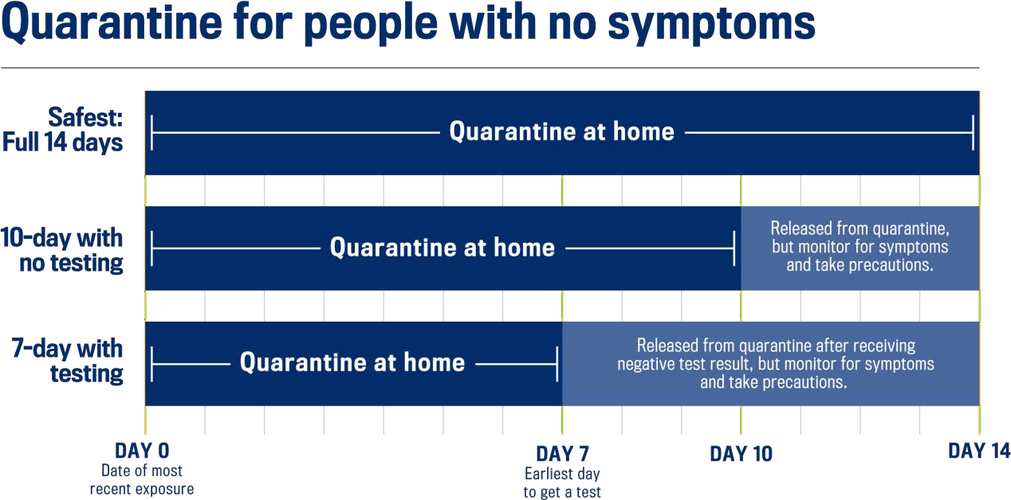
- Please note that if the COVID-19 exposure is within your own household, the “7-day with testing” quarantine option does not apply. Your child many need to quarantine longer than 10 days depending on the situation.

- If your child has tested positive in the last 90 days or completed the vaccine series (e.g., two weeks after the second dose), your child may be exempt from quarantine if your child is not experiencing symptoms:

  - Get tested 3-5 days following the last day of known exposure to someone with suspected or confirmed COVID-19.
  - Wear a mask in public indoor settings for 14 days or until your child receives a negative test result.
  - If there is a confirmed positive case in your household, your child may need to stay home until your household is no longer contagious.

6800 Old Main Hill, Logan, UT 84322-6800 • 435-797-1981 • idrpp.usu.edu

