Parent Portal Primary Family Unit
This document provides an overview of who can view documents in the Parent Portal.

Currently, BTOTS only provides Parent Portal access to members of the “Primary Family Unit” under the contact tab as shown in Figure 1. Once a contact is moved to an “Additional Family Unit” the contact no longer has access to the parent portal or the documents.

Figure 1. Primary Family Unit Example
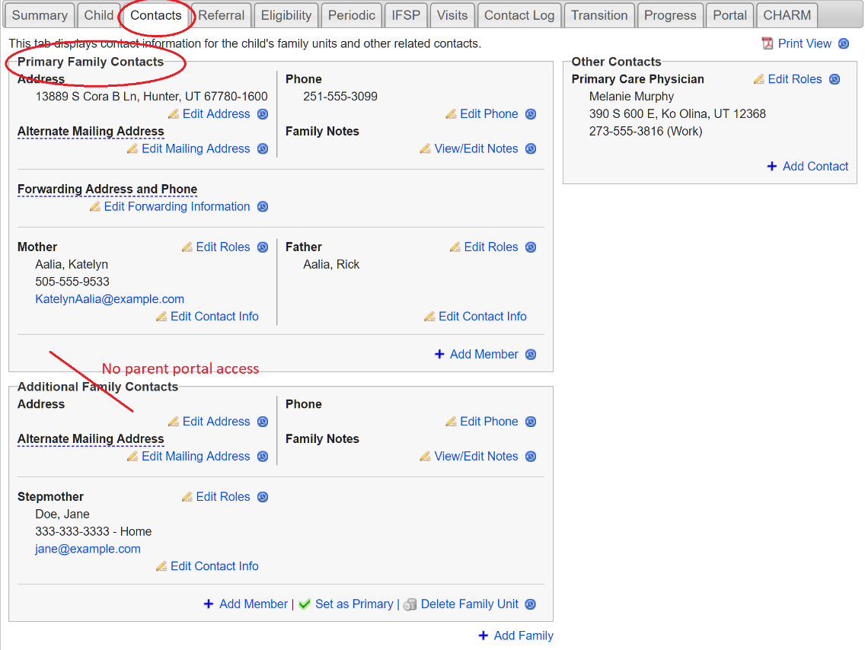

Roles Needing “Primary Contact Role” Added for Portal Access
As well as being under the “Primary Family Contact Unit,” the contact must also be a certain “Role.” Roles that may need a primary contact role added are: Grandmother, Grandfather, sibling, and emergency contact. These roles will NOT have access to the Parent Portal unless the role of “Primary Contact” is also selected as shown in Figure 2.

Figure 2. Primary Family Unit and “Roles”
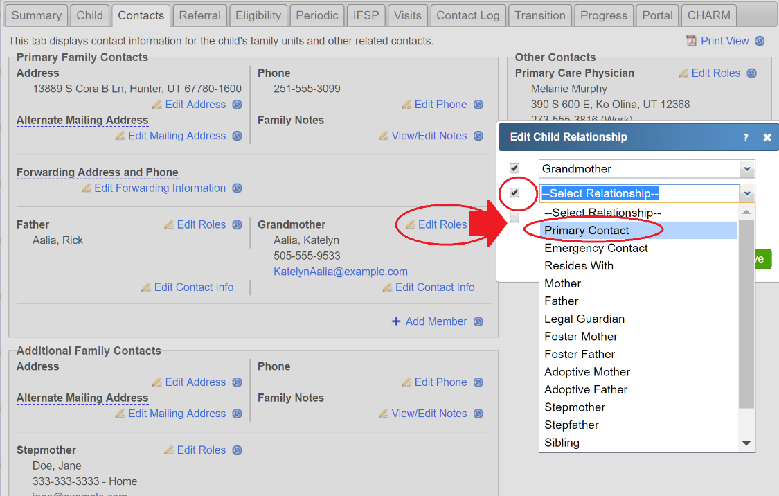

Primary Family Contacts and Transfers

When a child transfers to a new program, only the child’s primary contacts, by default, will transfer to the new program. The newly issued email for the Parent Portal will only provide primary contacts access to the new program’s information and documents. However, through emails sent from the previous program, primary contacts will continue to have access to documents created by the previous program for 90 days after the transfer.

Changes in Guardianship

Please see the following suggestions for dealing with changes in guardianship in the BTOTS system.
- When guardianship changes, update the contact information in the child’s folder. Signing or Resigning the IFSP will place the correct contact information in the signed IFSP.
- Do not set up access to the Parent Portal for the new family. Rather, only share paper documents, and manually redact any PI information on previous IFSPs and notes.
- Under the BTOTS Contact tab, use the “Add Family” link to create a "New Family" and save this information as shown in Figure 3.

Figure 3. Add Family
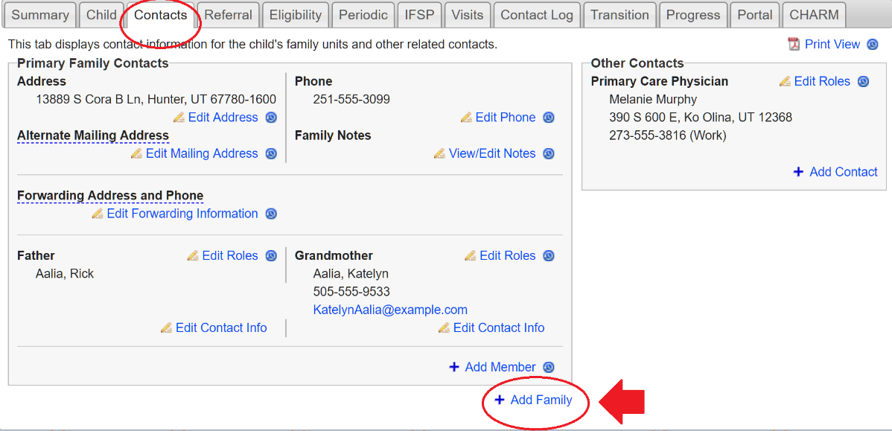
  - Use the “Set as Primary” link to make the newly created family unit the "Primary Family" contact as shown in Figure 4.

Figure 4. Set as Primary
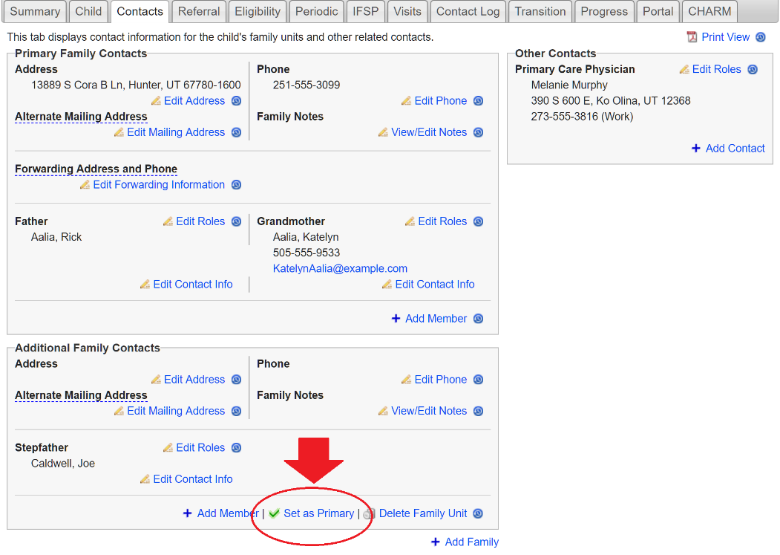

  - As an extra precautionary measure to help ensure PI information does not get exchanged, do not enter an email address.
  - Under the Contact tab, check the Do Not Release box(es) next to all of the prior family's information as shown in Figure 5.

Figure 5. Do Not Release
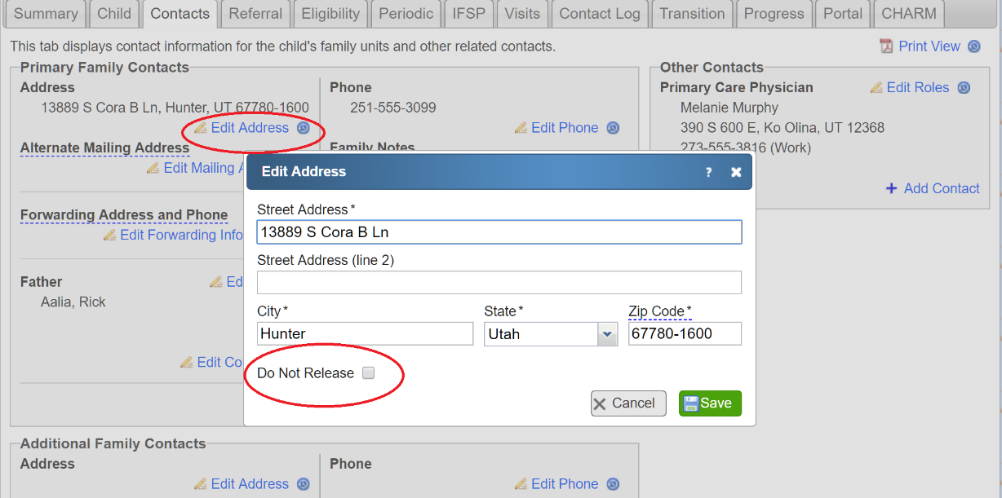

  - In addition, you can make a note in the contact tab to inform providers that the family/families is/are not currently subscribed to the parent portal for confidentiality reasons.
- As an additional reminder, you can also create an alert on the child's Summary page in BTOTS to inform folks who are providing services to the child of the current situation.

Please Note: Unsubscribing a contact for the Parent Portal prevents any further emails from being sent. However, the contact could still access child document using previously received emails (e.g., they are not blocked from parent portal access).

