Self-Evaluation Checklist
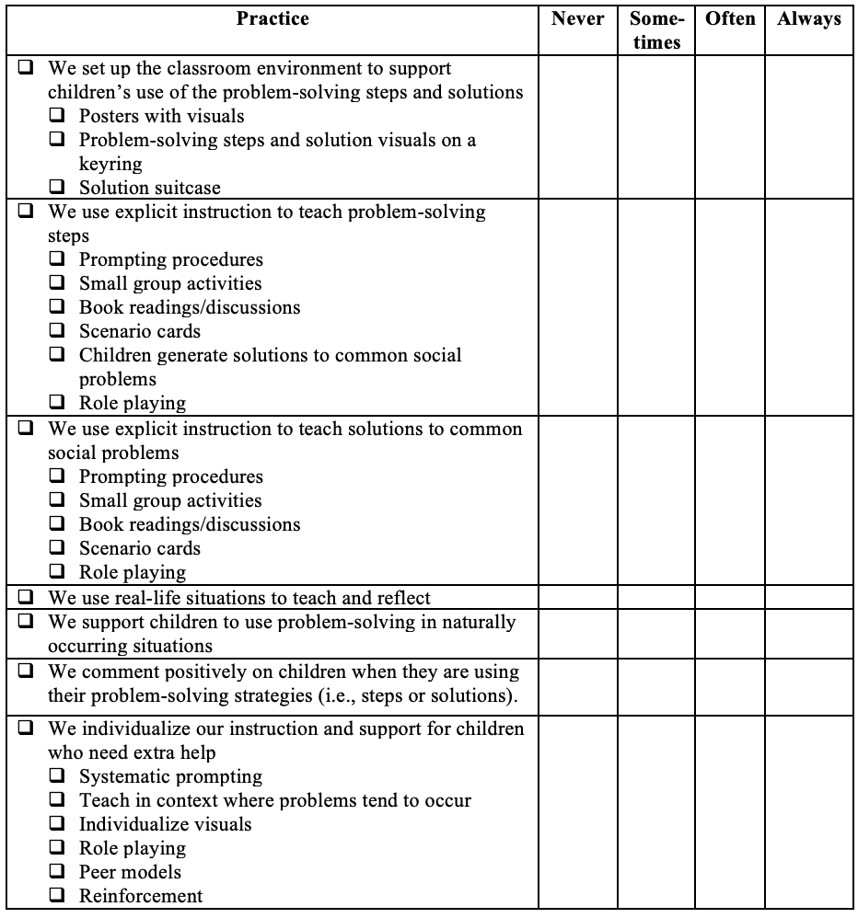Golden, A., Taylor, A.L., Korba, J., & Hemmeter, M.L. (2021). Teaching Social Problem Solving. In M. L. Hemmeter, M. M. Ostrosky, & L. Fox (Ed.), Unpacking the Pyramid Model: A practical guide for preschool teachers. (pp. 119-129). Brookes.

