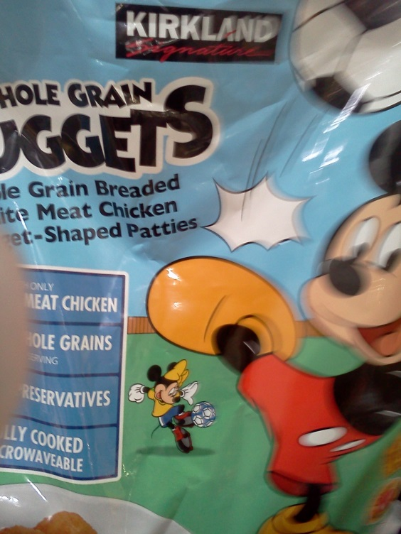
According to the CN label
5 chicken nuggets=1.5 meat and .75 Bread

Snack | 1-2 | 3-5 | 6-12
Meat/meat alternate amount required | ½ oz. | ½ oz. | 1 oz.
Meat/meat alternate-  # pieces you would need to offer | 2 | 2 | 3
Amount grain you would need | ½ slice | ½ slice | 1 slice
Grain-# pieces you would need to offer | 2.5 | 2.5 | 5
Lunch/Supper
Meat/meat alternate amount required | 1 oz. | 1.5 oz. | 2 oz.
Meat/meat alternate-  # pieces you would need to offer | 3 | 4 | 5
Amount of grain you would need | ½ slice | ½ slice | 1 slice
Grain-# pieces you would need to offer | 2.5 | 2.5 | 5

