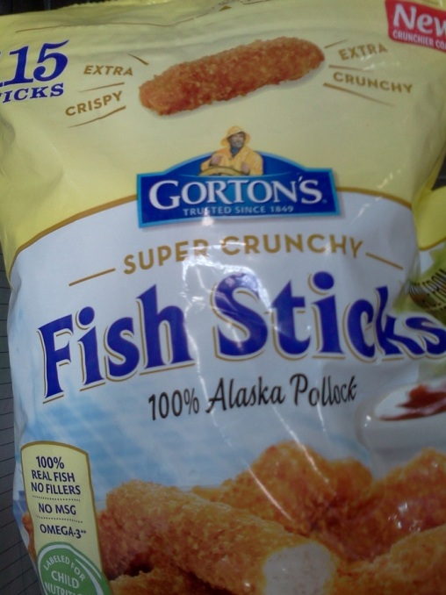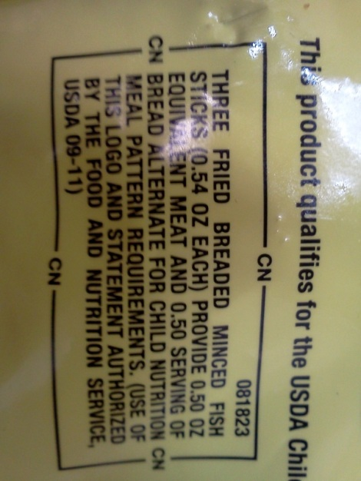
Snack | 1-2 | 3-5 | 6-12
Meat/meat alternate amount required | ½ oz. | ½ oz. | 1 oz.
Meat/meat alternate-  # pieces you would need to offer | 3 | 3 | 6
Grain-# pieces you would need to offer | 3 | 3 | 6
Lunch/Supper
Meat/meat alternate amount required | 1 oz. | 1.5 oz. | 2 oz.
Meat/meat alternate-  # pieces you would need to offer | 6 | 9 | 12
Grain-# pieces you would need to offer | 6 | 9 | 12

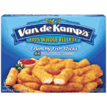
Van de Kamp’s whole fillets crunchy fish sticks 24.6 oz
Snack | 1-2 | 3-5 | 6-12
Meat/meat alternate amount required | ½ oz. | ½ oz. | 1 oz.
Meat/meat alternate-  # pieces you would need to offer | 3 | 3 | 6
Grain-# pieces you would need to offer | Not credible
Lunch/Supper
Meat/meat alternate amount required | 1 oz. | 1.5 oz. | 2 oz.
Meat/meat alternate-  # pieces you would need to offer | 6 | 9 | 12
Grain-# pieces you would need to offer | Not credible

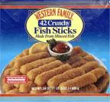
Western Family Crunchy
Minced Pollock fish sticks 24 oz.
Snack | 1-2 | 3-5 | 6-12
Meat/meat alternate amount required | ½ oz. | ½ oz. | 1 oz.
Meat/meat alternate-  # pieces you would need to offer | 3 | 3 | 5
Grain | Not credible
Lunch/Supper
Meat/meat alternate amount required | 1 oz. | 1.5 oz. | 2 oz.
Meat/meat alternate-  # pieces you would need to offer | 5 | 8 | 10
Grain- | Not credible

