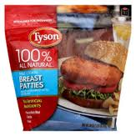
Tyson Breast Patties 26 oz.
Snack | 1-2 | 3-5 | 6-12
Meat/meat alternate amount required | ½ oz. | ½ oz. | 1 oz.
Meat/meat alternate-  # pieces you would need to offer | ½ pattie | ½ pattie | 1 pattie
Grain | Not credible
Lunch/Supper
Meat/meat alternate amount required | 1 oz. | 1.5 oz. | 2 oz.
Meat/meat alternate-  # pieces you would need to offer | 1 pattie | 1.5 patties | 2 pattie
Grain | Not credible

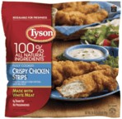
Tyson Crispy Chicken Strips 25 oz.
Snack | 1-2 | 3-5 | 6-12
Meat/meat alternate amount required | ½ oz. | ½ oz. | 1 oz.
Meat/meat alternate-  # pieces you would need to offer | 1.5 | 1.5 | 2
Grain | Not credible
Lunch/Supper
Meat/meat alternate amount required | 1 oz. | 1.5 oz. | 2 oz.
Meat/meat alternate-  # pieces you would need to offer | 2 | 2 | 3
Grain | Not credible

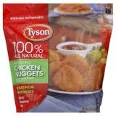
Tyson Chicken Nuggets 29 oz.
Snack | 1-2 | 3-5 | 6-12
Meat/meat alternate amount required | ½ oz. | ½ oz. | 1 oz.
Meat/meat alternate-  # pieces you would need to offer | 2 | 2 | 4
Grain- | Not credible
Lunch/Supper
Meat/meat alternate amount required | 1 oz. | 1.5 oz. | 2 oz.
Meat/meat alternate-  # pieces you would need to offer | 4 | 5 | 7
Grain | Not credible

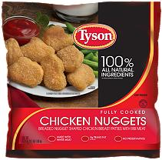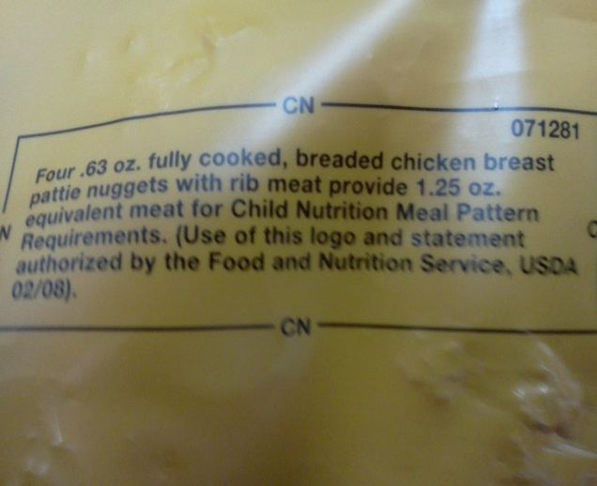
67.2 oz. bag: found this bag at Sam’s club

Snack | 1-2 | 3-5 | 6-12
Meat/meat alternate amount required | ½ oz. | ½ oz. | 1 oz.
Meat/meat alternate-  # pieces you would need to offer | 2 | 2 | 4
Grain | Not credible
Lunch/Supper
Meat/meat alternate amount required | 1 oz. | 1.5 oz. | 2 oz.
Meat/meat alternate-  # pieces you would need to offer | 4 | 6 | 8
Grain | Not credible
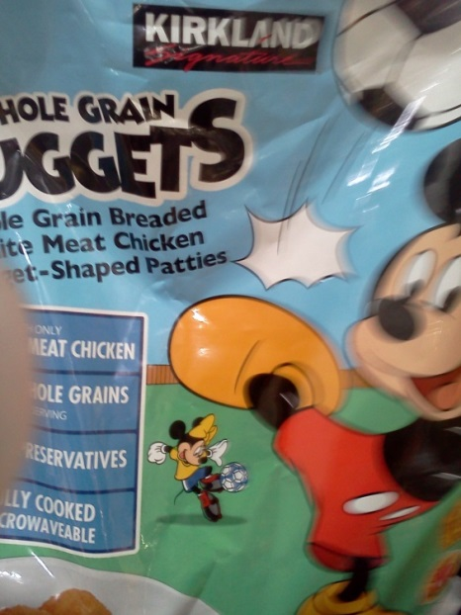
According to the CN Label Foster Farms Chicken breast nuggets
5 chicken nuggets + 1.5 meat and .75 bread
I found these at Costco
Snack | 1-2 | 3-5 | 6-12
Meat/meat alternate amount required | ½ oz. | ½ oz. | 1 oz.
Meat/meat alternate-  # pieces you would need to offer | 2 | 2 | 4
Amount grain you would need | ½ serving | ½ serving | 1 serving
Grain-# pieces you would need to offer | 4 | 4 | 8
Lunch/Supper
Meat/meat alternate amount required | 1 oz. | 1.5 oz. | 2 oz.
Meat/meat alternate-  # pieces you would need to offer | 4 | 5 | 8
Amount of grain you would need | ½ serving | ½ serving | 1 serving
Grain-# pieces you would need to offer | 4 | 4 | 8

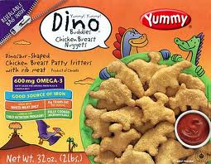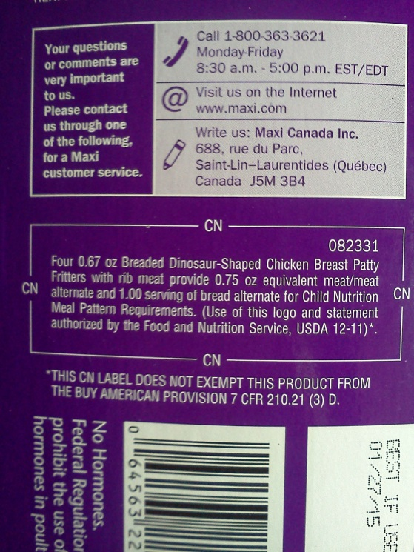

Dino Chicken Breast Nuggets 46 oz.
Snack | 1-2 | 3-5 | 6-12
Meat/meat alternate amount required | ½ oz. | ½ oz. | 1 oz.
Meat/meat alternate-  # pieces you would need to offer | 3 | 3 | 4
Grain-# pieces you would need to offer | 2 | 2 | 4
Lunch/Supper
Meat/meat alternate amount required | 1 oz. | 1.5 oz. | 2 oz.
Meat/meat alternate-  # pieces you would need to offer | 4 | 6 | 8
Grain-# pieces you would need to offer | 4 | 6 | 8

